Creative Writing
One Semester (.5 Credit)

Arkansas
English Language Arts Standards
2016

Course Title: Creative Writing
Course/Unit Credit: 0.5
Course Number: 417010
Teacher Licensure: Please refer to the Course Code Management System (https://adedata.arkansas.gov/ccms/) for the most current licensure codes.
Grades: 9-12

Creative Writing – One Semester

Creative Writing is a one-semester English elective course designed to engage students in the writing of poetry, short fiction, personal narratives, and other genres with an emphasis on developing and exercising imagination. Students will read closely for multiple purposes to analyze and evaluate exemplary texts to develop creative writing skills. Students will critique and refine writing through guided discussions, collaborative revisions, and individual reflections. Students will produce a portfolio of creative work that reflects student growth and understanding of the techniques of published authors. Students will share writing in a variety of ways and research methods for publishing original work. Creative Writing does not require Arkansas Department of Education approval.

Strand Content Standard
Reading
- Students will read a variety of texts for the purpose of analyzing styles, techniques, devices, and language in order to develop their own voice and style of writing.
Writing
- Students will use a range of writing techniques to produce original compositions in a variety of genres for multiple purposes and audiences.

Notes:
- Student Learning Expectations (SLEs) may be taught in any sequence.
- Italicized words in this document appear in the glossary.
- All items in a bulleted list are required to be taught.
- The examples given (e.g.,) are suggestions to guide the instructor.

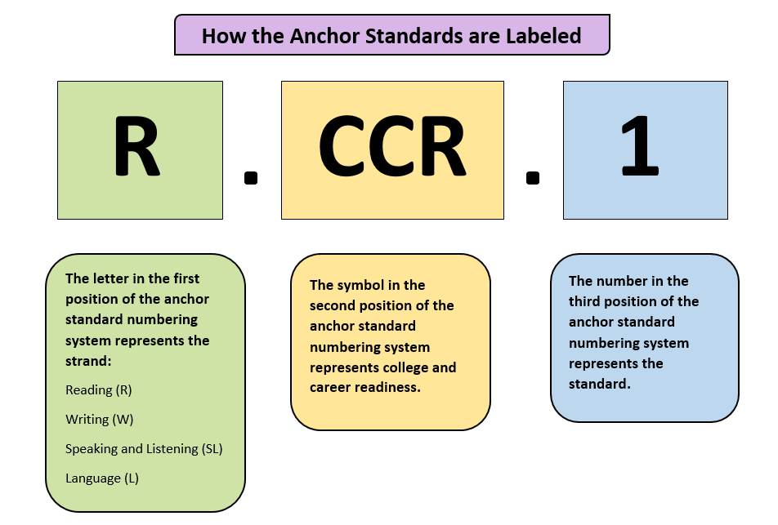
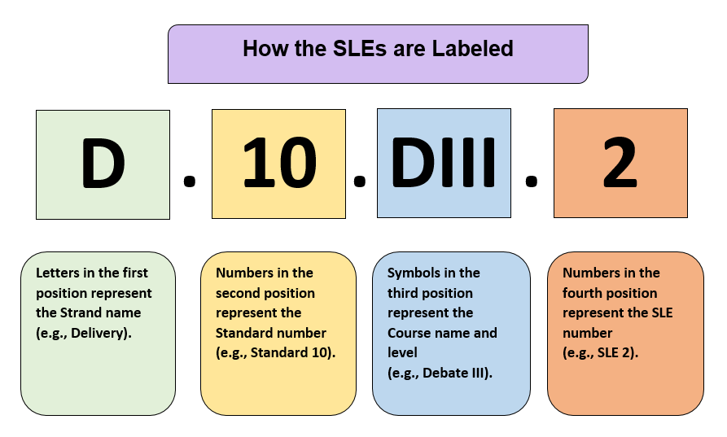

Strand: Reading
Content Standard 1: Students will read a variety of texts for the purpose of analyzing styles, techniques, devices, and language in order to
develop their own voice and style of writing.

AR ELA Alignment
R.1.CW.1 | Analyze the function and effect of literary devices, poetic devices, narrative techniques, and structure in a variety of texts from a writer’s perspective | R.CCR.1, R.CCR.4, R.CCR.5, R.CCR.6
R.1.CW.2 | Analyze a variety of genres, including but not limited to poetry, personal narratives, and short fiction, for authorial choices (e.g., word choices, syntax, cadence, character development, dialogue, plot development), author’s purpose, and effects on the reader | R.CCR.3, R.CCR.4, R.CCR.5, R.CCR.6
R.1.CW.3 | Read a variety of excerpts and texts from authors representing multiple cultures and perspectives (e.g., world regions, ethnicities, beliefs and philosophies, socio-economic and sociological viewpoints) to enhance and inspire student writing | R.CCR.6, R.CCR.7, R.CCR.9
R.1.CW.4 | Analyze focused excerpts about the craft of creative writing in a variety of sources (e.g., blogs, websites, literary magazines, essays, books) | R.CCR.4, R.CCR.5, R.CCR.6

Strand: Writing
Content Standard 2: Students will use a range of writing techniques to produce original compositions in a variety of genres for multiple
purposes and audiences.

AR ELA Alignment
W.2.CW.1 | Write poetry using a range of poetic devices that demonstrates understanding of the genre and is appropriate to audience and purpose | W.CCR.4, W.CCR.5, W.CCR.10
W.2.CW.2 | Write personal narratives that arise from problems, situations, observations, or experiences, using a range of literary devices and narrative techniques | W.CCR.3, W.CCR.4, W.CCR.5, W.CCR.10
W.2.CW.3 | Write short fiction using literary elements and a range of literary devices and narrative techniques | W.CCR.3, W.CCR.4, W.CCR.5, W.CCR.10
W.2.CW.4 | Produce creative writing (e.g., blog, article, essay, graphic novel, comic strip, screen play, script, drama) that demonstrates an understanding of multiple genres appropriate to audience and purpose | W.CCR.3, W.CCR.4, W.CCR.5, W.CCR.6,  W.CCR.9, W.CCR.10
W.2.CW.5 | Apply literary devices, narrative techniques, and a variety of stylistic devices (e.g., vivid word choice, abstract versus concrete language, descriptive language, sensory details, tone, voice, persona) in student writing | W.CCR.3, W.CCR.4, W.CCR.5, W.CCR.10
W.2.CW.6 | Revise student writing during the writing process using self and peer review (e.g., rubrics, writing conferences, writing groups, feedback) | W.CCR.5, W.CCR.6
W.2.CW.7 | Edit during the writing process for standard conventions (e.g., mechanics, usage, grammar, agreement, spelling, punctuation) as appropriate for the genre | W.CCR.5, W.CCR.6
W.2.CW.8 | Maintain a portfolio of student work that reflects growth in creative writing | W.CCR.6, W.CCR.10
W.2.CW.9 | Research a variety of methods and criteria for publishing original student works (e.g., school newspaper, literary magazine, online journal, school/class anthology, writing contests) | W.CCR.6

Glossary for Creative Writing

Literary elements | Universal components that writers purposefully use to develop a literary piece and can be found in any written or oral story (e.g., antagonist, conflict, narrator, plot, protagonist, setting, theme)
Literary devices | Components of literature that can be found in written text but are not universal (e.g., characterization, diction, figurative language, flashback, foreshadowing, imagery, irony, satire, suspense, symbolism)
Narrative techniques | Methods authors use to develop the narrative, making it more complete, complicated, or interesting (e.g., back story, cliff hanger, flashback, flash forward, foreshadowing) for the audience
Poetic devices | Devices and methods that affect the sound (e.g., alliteration, assonance, onomatopoeia, repetition, rhyme, rhythm), meaning (e.g., allusion, ambiguity, apostrophe, hyperbole, imagery, irony, metaphor, oxymoron, paradox, personification, simile, symbolism), arrangement (e.g., line, point of view, rhyme scheme, stanza, verse), and form (e.g., ballad, blank verse, free verse, haiku) in poetry

Contributors

The following people contributed to the development of this document:

Jennifer Akers - Cabot | Amy Matthews - Fayetteville
Tammy Alexander - Nashville | Gerri McCann - Manila
Rebecca Allen - Valley View | Amanda McMahan - Magnolia
Jane Balgavy - Jacksonville-North Pulaski | Lynn Meade - University of Arkansas
Brandon Box-Higdem - Bentonville | Alisa Melton - Blytheville
Samantha Carpenter - Virtual Arkansas | Jennifer Murphy - El Dorado
Lisa Carver - Texarkana | Traci Myers - Foreman
Kimberly Chavez - Camden Fairview | Tim Peerbolte - Greenwood
Susan Colyer - Fort Smith | Erin Radke - Jessieville
Joan Crowder - Arkadelphia | Jacki Reiff - Gravette
April Erickson - South Conway County | Tracie Richard - Hermitage
Jessica Foster - Siloam Springs | Chad Simpson - Clarendon
Sommer Frazer - McGehee | Dallas Sims - Lakeside (Lake Village)
Natalie Free - Pangburn | Vivian Sisk – KIPP: Delta Collegiate
Eric Gamble - Dardanelle | Andrea Speer - Bentonville
Jennifer Garner - Lakeside (Hot Springs) | Steven Trulock - Huntsville
Roger Guevara - Southern Arkansas University | Rosie Valdez - Little Rock
Shelly Hardin - West Memphis

