Debate IV

Arkansas
English Language Arts Standards
2016

Course Title: Debate IV
Course/Unit Credit: 1
Course Number: 414080
Teacher Licensure: Please refer to the Course Code Management System (https://adedata.arkansas.gov/ccms/) for the most current licensure codes.
Grades: 9-12
Prerequisite: Debate III

Debate IV

Debate III is a prerequisite for Debate IV. Students entering Debate II, III, or IV must have successfully completed the preceding year of study. Debate I is a two-semester foundational course and cannot be combined with other courses. Debate II-IV may be taught within the same class period; however, the student learning expectations for each level are different and must be addressed.

Debate II, III, and IV lead students to a mastery of advanced argumentation skills. Students will construct and present argumentative positions using scholarly research on complex, controversial issues. Content will include oral advocacy in relation to the legal system and the democratic process. Peer adjudication will be an important part of the advanced Debate courses. The two-semester courses of Debate II, III, and IV do not require Arkansas Department of Education approval.

Debate IV

Strand Content Standard
Communication Skills
(Taught in Level 1 and reinforced in Levels II, III, & IV)
- Students will demonstrate fundamental oral communication competencies.
- Students will demonstrate understanding of the variety of debate styles.
- Students will identify and apply the necessary tools for debate.
- Students will develop persuasive speaking skills.
Argumentation
- Students will identify and present the three parts of an argument (claim, warrant, impact).
- Students will utilize research skills and collect well-sourced evidence.
- Students will apply appropriate speech organization.
Refutation
- Students will analyze and rebut opposing arguments.
- Students will utilize effective questioning strategies.
Delivery
- Students will participate in debates within or outside of the classroom.
- Students will evaluate debates and provide feedback.
Advocacy
- Students will synthesize socioeconomic, ethical, and/or philosophical reasoning that influences current issues.
- Students will develop individual and group perspectives on the importance of debate to both local and global communities.
- Students will participate in community outreach, culminating in competitive debate in or outside of the classroom.

Notes:
- Throughout this document, the terms competition and competitive event occur frequently. These terms refer to events that may occur within or outside of the school. The purpose of these courses is to provide students with debate fundamentals and tools of mastery and provide guidance for how to practice these in a competitive atmosphere.
- The Communication Skills strand appears only in Debate I. This provision allows Debate I to meet the state Oral Communication requirement.
- Each level continues to address earlier student learning Expectations (SLEs) as needed.
- Student Learning Expectations (SLEs) may be taught in any sequence.
- Italicized words in this document appear in the glossary.
- All items in a bulleted list are required to be taught.
- The examples given (e.g.,) are suggestions to guide the instructor.
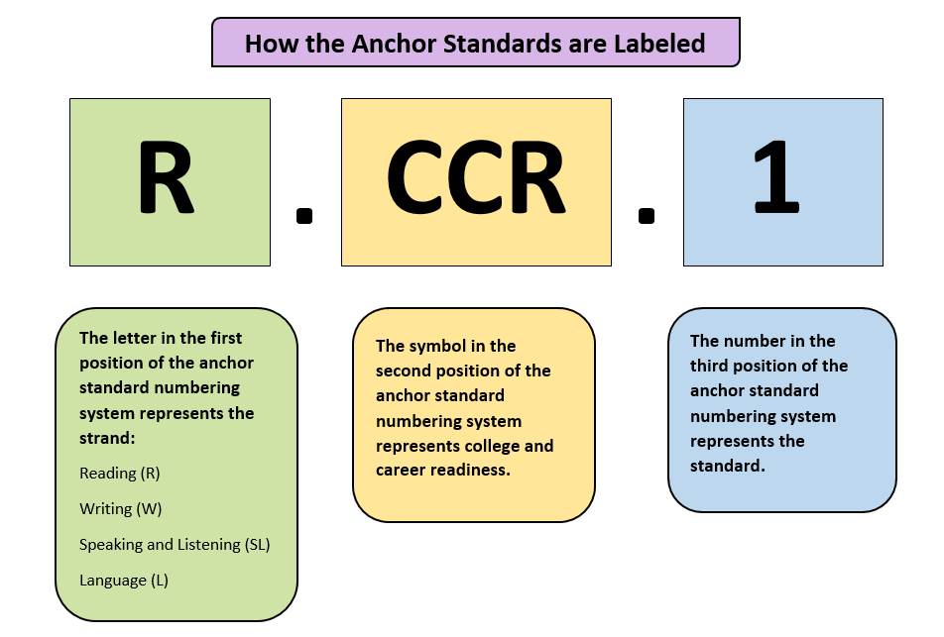
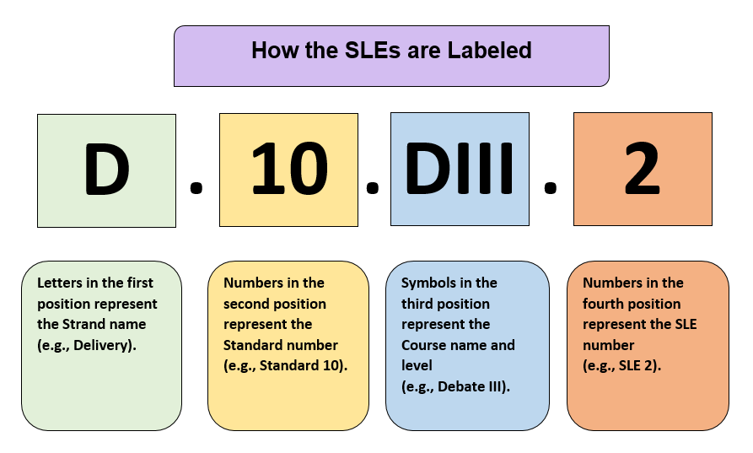

Strand: Communication Skills
Content Standard 1: Students will demonstrate fundamental oral communication competencies.

AR ELA Alignment
CS.1.DIV.1 | This SLE is taught in Debate I and should be reinforced as needed.  Demonstrate effective verbal communication:  - clarity  - diction and word economy  - elimination of verbal fillers  - inflection  - speed of delivery | SL.CCR.4, SL.CCR.6
CS.1.DIV.2 | This SLE is taught in Debate I and should be reinforced as needed.  Implement effective nonverbal communication:  - control of facial expressions  - eye contact  - gesturing and posture  - pauses  - proximity
CS.1.DIV.3 | This SLE is taught in Debate I and should be reinforced as needed.  Utilize effective listening practices (e.g., note-taking, active listening feedback) | W.CCR.10, SL.CCR.1, SL.CCR.3
CS.1.DIV.4 | This SLE is taught in Debate I and should be reinforced as needed.  Discuss ethical practices:  - academic honesty  - appropriate cutting of evidence  - courtesy  - proper citation  - respect for diversity | SL.CCR.1, SL.CCR.4, SL.CCR.6

Strand: Communication Skills
Content Standard 2: Students will demonstrate understanding of the variety of debate styles.

AR ELA Alignment
CS.2.DIV.1 | This SLE is taught in Debate I and should be reinforced as needed.  Identify the different types of debate (e.g., policy, Lincoln-Douglas, public forum, International Public Debate Association [IPDA], student congress/parliamentary, mock trial, world school, big question, extemporaneous)
CS.2.DIV.2 | This SLE is taught in Debate I and should be reinforced as needed.  Compare and contrast the various styles of debate | R.CCR.9
CS.2.DIV.3 | This SLE is taught in Debate I and should be reinforced as needed.  Practice skills associated with various styles of debate | SL.CCR.6

Strand: Communication Skills
Content Standard 3: Students will identify and apply the necessary tools for debate.

AR ELA Alignment
CS.3.DIV.1 | This SLE is taught in Debate I and should be reinforced as needed.  Speak within time parameters for various styles of debate | SL.CCR.6
CS.3.DIV.2 | This SLE is taught in Debate I and should be reinforced as needed.  Complete specialized debate flows | W.CCR.4, W.CCR.10
CS.3.DIV.3 | This SLE is taught in Debate I and should be reinforced as needed.  Access evidence databases and online resources (e.g., www.debatecoaches.org, www.speechanddebate.org, www.actaa.net) | W.CCR.8
CS.3.DIV.4 | This SLE is taught in Debate I and should be reinforced as needed.  Utilize electronic file organization (e.g., Dropbox, Google Drive, Verbatim) | R.CCR.7, W.CCR.6

Strand: Communication Skills
Content Standard 4: Students will develop persuasive speaking skills.

AR ELA Alignment
CS.4.DIV.1 | This SLE is taught in Debate I and should be reinforced as needed.  Identify tools of persuasion:  - ethos  - pathos  - logos | R.CCR.8
CS.4.DIV.2 | This SLE is taught in Debate I and should be reinforced as needed.  Establish impact framing:  - impact comparison  - time frame, magnitude, probability  - risk assessment  - speech overviews | SL.CCR.4, SL.CCR.6
CS.4.DIV.3 | This SLE is taught in Debate I and should be reinforced as needed.  Adapt to opponents, audience, and judge  - content warnings  - microaggressions  - paradigms (e.g., tabula rasa, policy maker, hypotesting,  comparative advantage)  - sensitivity  - spreading | SL.CCR.6

Strand: Argumentation
Content Standard 5: Students will identify and present the three parts of an argument (claim, warrant, impact)

AR ELA Alignment
ARG.5.DIV.1 | Apply advanced argumentation across a broad spectrum | SL.CCR.3, SL.CCR.4, SL.CCR.5, SL.CCR.6
ARG.5.DIV.2 | Apply philosophical context to arguments (e.g., utilitarianism, value to life, dehumanization) | SL.CCR.4, SL.CCR.6
ARG.5.DIV.3 | Weigh impacts within philosophical context | W.CCR.6, SL.CCR.3

Strand: Argumentation
Content Standard 6: Students will utilize research skills and collect well-sourced evidence.

AR ELA Alignment
ARG.6.DIV.1 | Instruct use of evidence to novice debaters | R.CCR.1, W.CCR.1, W.CCR.8, W.CCR.9, SL.CCR.1, SL.CCR.3, SL.CCR.4, SL.CCR.5
ARG.6.DIV.2 | This SLE is taught in Debate III and should be reinforced as needed.  Categorize evidence (e.g., flow grouping, cross-application) | R.CCR.7, W.CCR.8, W.CCR.9, W.CCR.10
ARG.6.DIV.3 | This SLE is taught in Debate III and should be reinforced as needed.  Develop arguments based on evidence | W.CCR.1, W.CCR.4, W.CCR.7, W.CCR.8, W.CCR.9, W.CCR.10, W.CCR.4, W.CCR.5, W.CCR.6, L.CCR.1, L.CCR.3, L.CCR.6
ARG.6.DIV.4 | Generate strategy guides using feedback (e.g., ballots, Reasons for Decisions (RFDs), peer reviews, oral critiques) | W.CCR.2, W.CCR.4, W.CCR.10, SL.CCR.1, SL.CCR.2, SL.CCR.3, SL.CCR.4, SL.CCR.5, SL.CCR.6, L.CCR.1

Strand: Argumentation
Content Standard 7: Students will apply appropriate speech organization.

AR ELA Alignment
ARG.7.DIV.1 | Produce flows for the purpose of novice education | W.CCR.4, W.CCR.6, W.CCR.10
ARG.7.DIV.2 | Create blocks | W.CCR.1, W.CCR.4, W.CCR.6, W.CCR.7, W.CCR.8, W.CCR.9, W.CCR.10
ARG.7.DIV.3 | Affect clash using the priority of arguments | W.CCR.1, W.CCR.4, SL.CCR.4, SL.CCR.6
ARG.7.DIV.4 | Combine evidence and line-by-line analysis seamlessly | W.CCR.4, W.CCR.8, W.CCR.9, W.CCR.10, SL.CCR.3, SL.CCR.4, SL.CCR.6, L.CCR.1, L.CCR.3

Strand: Refutation
Content Standard 8: Students will analyze and rebut opposing arguments.

AR ELA Alignment
R.8.DIV.1 | Design multiple offensive positions (e.g., briefs, shells, pre-written rebuttals) | W.CCR.1, W.CCR.4, W.CCR.5, W.CCR.6, W.CCR.7, W.CCR.8, W.CCR.9, W.CCR.10, L.CCR.1, L.CCR.2, L.CCR.3, L.CCR.6
R.8.DIV.2 | Demonstrate and evaluate effectiveness of offensive strategies in competition | SL.CCR.3, SL.CCR.4, SL.CCR.6, L.CCR.1, L.CCR.3

Strand: Refutation
Content Standard 9: Students will utilize effective questioning strategies.

AR ELA Alignment
R.9.DIV.1 | Deploy strategies at the master level (e.g., varsity) | SL.CCR.4, SL.CCR.5, SL.CCR.6, L.CCR.1, L.CCR.3, L.CCR.6
R.9.DIV.2 | Model speaker positions for novice debaters (e.g., student lectures, demonstration debates, observation of competition) | SL.CCR.1, SL.CCR.3, SL.CCR.4, SL.CCR.5, SL.CCR.6

Strand: Delivery
Content Standard 10: Students will participate in debates within or outside of the classroom.

AR ELA Alignment
D.10.DIV.1 | This SLE is taught in Debate II and should be reinforced as needed.  Determine personal strengths and weaknesses across debate styles | SL.CCR.6
D.10.DIV.2 | Synthesize theoretical implications of debate arguments | SL.CCR.3, SL.CCR.6
D.10.DIV.3 | Compete at the master level (e.g., varsity) | SL.CCR.1, SL.CCR.2, SL.CCR.3, SL.CCR.4, SL.CCR.5, SL.CCR.6, L.CCR.1, L.CCR.3, L.CCR.6

Strand: Delivery
Content Standard 11: Students will evaluate debates and provide feedback.

AR ELA Alignment
D.11.DIV.1 | Evaluate peers using criteria (e.g., volunteer judging at junior high tournaments) | SL.CCR.3
D.11.DIV.2 | Refine oral critiques and written feedback | W.CCR.5, SL.CCR.3, SL.CCR.6, L.CCR.1

Strand: Advocacy
Content Standard 12: Students will synthesize socioeconomic, ethical, and/or philosophical reasoning that influences current issues.

AR ELA Alignment
ADV.12.DIV.1 | Participate in dialogue and service that promotes social advocacy (e.g., analyze televised debate events, debate tournaments, in-class critiques) | SL.CCR.1, SL.CCR.2, SL.CCR.3, SL.CCR.4, SL.CCR.5, SL.CCR.6
ADV.12.DIV.2 | Defend policy change through a philosophical lens | W.CCR.1, SL.CCR.1, SL.CCR.2, SL.CCR.3, SL.CCR.4, SL.CCR.5, SL.CCR.6
ADV.12.DIV.3 | Articulate alternatives to the status quo | SL.CCR.4, SL.CCR.5, SL.CCR.6

Strand: Advocacy
Content Standard 13: Students will develop individual and group perspectives on the importance of debate to both local and global
communities.

AR ELA Alignment
ADV.13.DIV.1 | Implement plans with the community | W.CCR.6, SL.CCR.1, SL.CCR.2, SL.CCR.4, SL.CCR.5, SL.CCR.6, L.CCR.1, L.CCR.2, L.CCR.3, L.CCR.6
ADV.13.DIV.2 | Apply methods to promote advocacy | W.CCR.6, SL.CCR.1, SL.CCR.2, SL.CCR.4, SL.CCR.5, SL.CCR.6, L.CCR.1, L.CCR.2, L.CCR.3, L.CCR.6

Strand: Advocacy
Content Standard 14: Students will participate in community outreach, culminating in competitive debate in or outside of the classroom.

AR ELA Alignment
ADV.14.DIV.1 | Direct a competitive event in or outside of the classroom:  - collaboration among teacher, student, and administration  - student leadership | SL.CCR.1, SL.CCR.4, SL.CCR.5, SL.CCR.6
ADV.14.DIV.2 | Participate in a competition at the master level (e.g., varsity) | SL.CCR.1, SL.CCR.2, SL.CCR.3, SL.CCR.4, SL.CCR.5, SL.CCR.6
ADV.14.DIV.3 | Model assessment and response to feedback to novice debaters | SL.CCR.3, SL.CCR.6

Glossary for Debate IV

Blocks | A set of prepared arguments to include analysis/reasoning and evidence on a specific point, prepared in advance of a debate or during a debate
Claim | A statement that a debater supports or refutes with evidence and reasoning (e.g., “Schools should run year round” is a claim; “Wednesday comes after Tuesday” is not.)
Clash | Fundamental to debate; opposing arguments, Affirmative and Negative stances, on the key issues
Clipping | Failure of a debater to read all marked portions of the card while claiming to have done so
Cutting | Exact passages taken directly from articles, reports, books, speeches, and transcripts used as evidence in debate
Flow | Detailed, shorthand notes taken during a debate round to keep track of all of the arguments made by both debaters/teams
Impact | Why the judge/someone in the round should care about an argument, and how winning the argument affects the rest of the debate
Kicking | Strategically choosing to eliminate an argument(s) that has become irrelevant, dangerous, or incoherent
Line-by-line | Debate strategy in which a speaker directly answers each and every one of the opponents’ arguments one right after another in the order that they were given
Overviews | Distinct from line-by-line; appears at the beginning of a speech to highlight key offensive points for a debater or team, occurs within the time limits of a speech
Power tagging | The unethical practice of labeling a tagline in a way that grossly misrepresents the evidence used as support
Roadmap | Explanation of the order in which the debater’s next speech will address the issues surrounding the debate, directed to the judge, not added to the timed remarks
Spreading | The practice of increasing a debater’s speaking speed (150-300 words per minute) to allow for more argumentation within given time limits; also known as speed reading, not encouraged for every type of debate

Contributors

The following people contributed to the development of this document:

Jennifer Akers - Cabot | Amy Matthews - Fayetteville
Tammy Alexander - Nashville | Gerri McCann - Manila
Rebecca Allen - Valley View | Amanda McMahan - Magnolia
Jane Balgavy - Jacksonville-North Pulaski | Lynn Meade - University of Arkansas
Brandon Box-Higdem - Bentonville | Alisa Melton - Blytheville
Samantha Carpenter - Virtual Arkansas | Jennifer Murphy - El Dorado
Lisa Carver - Texarkana | Traci Myers - Foreman
Kimberly Chavez - Camden Fairview | Tim Peerbolte - Greenwood
Susan Colyer - Fort Smith | Erin Radke - Jessieville
Joan Crowder - Arkadelphia | Jacki Reiff - Gravette
April Erickson - South Conway County | Tracie Richard - Hermitage
Jessica Foster - Siloam Springs | Chad Simpson - Clarendon
Sommer Frazer - McGehee | Dallas Sims - Lakeside (Lake Village)
Natalie Free - Pangburn | Vivian Sisk – KIPP: Delta Collegiate
Eric Gamble - Dardanelle | Andrea Speer - Bentonville
Jennifer Garner - Lakeside (Hot Springs) | Steven Trulock - Huntsville
Roger Guevara - Southern Arkansas University | Rosie Valdez - Little Rock
Shelly Hardin - West Memphis

