Debate I

Arkansas
English Language Arts Standards
2016

Course Title: Debate I
Course/Unit Credit: 1
Course Number: 414050
Teacher Licensure: Please refer to the Course Code Management System (https://adedata.arkansas.gov/ccms/) for the most current licensure codes.
Grades: 9-12

Debate I

Debate I is a prerequisite for Debate II. Students entering Debate II, III, or IV must have successfully completed the preceding year of study. Debate I is a two-semester foundational course and cannot be combined with other courses. Debate II-IV may be taught within the same class period; however, the student learning expectations for each level are different and must be addressed.

Students in Debate I will gain an understanding of the fundamentals of argumentation and will express ideas and present information in a variety of oral advocacy situations from small group discussions to formal debates. Special emphasis will be given to research proficiencies and analytical thinking and listening skills. The skills listed in Strand 1: Communication Skills will be embedded throughout the course, providing students with an understanding of the dynamics of effective oral communication when speaking, listening, and responding. Debate I fulfills the .5 unit of Oral Communication required for graduation, and does not require Arkansas Department of Education approval.

Debate II, III, and IV lead students to a mastery of advanced argumentation skills. Students will construct and present argumentative positions using scholarly research on complex, controversial issues. Content includes oral advocacy in relation to the legal system and the democratic process. Peer adjudication will be an important part of the advanced Debate courses.
Debate I

Strand Content Standard
Communication Skills (Taught in Level 1 and reinforced in Levels II, III, & IV)
- Students will demonstrate fundamental oral communication competencies.
- Students will demonstrate understanding of the variety of debate styles.
- Students will identify and apply the necessary tools for debate.
- Students will develop persuasive speaking skills.
Argumentation
- Students will identify and present the three parts of an argument (claim, warrant, impact).
- Students will utilize research skills and collect well-sourced evidence.
- Students will apply appropriate speech organization.
Refutation
- Students will analyze and rebut opposing arguments.
- Students will utilize effective questioning strategies.
Delivery
- Students will participate in debates within or outside of the classroom.
- Students will evaluate debates and provide feedback.
Advocacy
- Students will synthesize socioeconomic, ethical, and/or philosophical reasoning that influences current issues.
- Students will develop individual and group perspectives on the importance of debate to both local and global communities.
- Students will participate in community outreach, culminating in competitive debate in or outside of the classroom.

Notes:
- Throughout this document, the terms competition and competitive event occur frequently. These terms refer to events that may occur within or outside of the school. The purpose of these courses is to provide students with debate fundamentals and tools of mastery and provide guidance for how to practice these in a competitive atmosphere.
- The Communication Skills strand appears only in Debate I. This provision allows Debate I to meet the state Oral Communication requirement.
- Student Learning Expectations (SLEs) may be taught in any sequence.
- Italicized words in this document appear in the glossary.
- All items in a bulleted list are required to be taught.
- The examples given (e.g.,) are suggestions to guide the instructor.

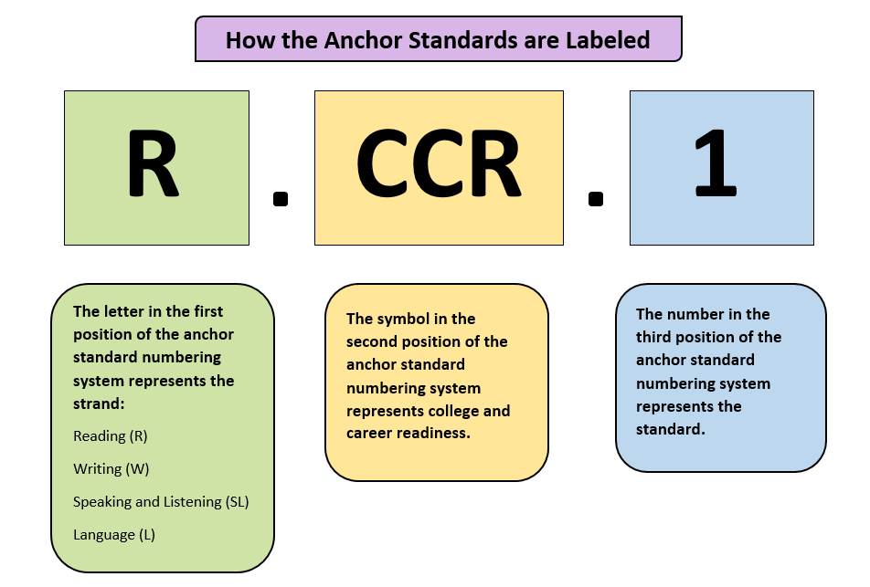

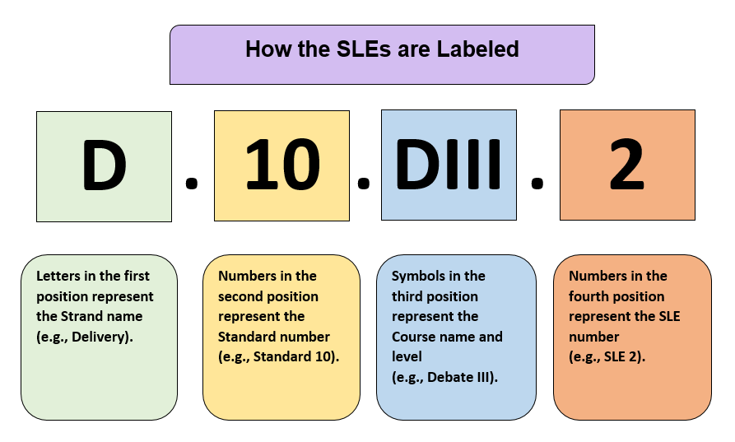
Strand: Communication Skills
Content Standard 1: Students will demonstrate fundamental oral communication competencies.

AR ELA Alignment
CS.1.DI.1 | Demonstrate effective verbal communication:  - clarity  - diction and word economy  - elimination of verbal fillers  - inflection  - speed of delivery | SL.CCR.4, SL.CCR.6
CS.1.DI.2 | Implement effective nonverbal communication:  - control of facial expressions  - eye contact  - gesturing and posture  - pauses  - proximity
CS.1.DI.3 | Utilize effective listening practices (e.g., note-taking, active listening feedback) | W.CCR.10, SL.CCR.1, SL.CCR.3
CS.1.DI.4 | Discuss ethical practices:  - academic honesty  - appropriate cutting of evidence  - courtesy  - proper citation  - respect for diversity | SL.CCR.1, SL.CCR.4, SL.CCR.6

Strand: Communication Skills
Content Standard 2: Students will demonstrate understanding of the variety of debate styles.

AR ELA Alignment
CS.2.DI.1 | Identify the different types of debate (e.g., policy, Lincoln-Douglas, public forum, International Public Debate Association [IPDA], student congress/parliamentary, mock trial, world school, big question, extemporaneous)
CS.2.DI.2 | Compare and contrast the various styles of debate | R.CCR.9
CS.2.DI.3 | Practice skills associated with various styles of debate | SL.CCR.6

Strand: Communication Skills
Content Standard 3: Students will identify and apply the necessary tools for debate.

AR ELA Alignment
CS.3.DI.1 | Speak within time parameters for various styles of debate | SL.CCR.6
CS.3.DI.2 | Complete specialized debate flows | W.CCR.4, W.CCR.10
CS.3.DI.3 | Access evidence databases and online resources (e.g., www.debatecoaches.org, www.speechanddebate.org, www.actaa.net) | W.CCR.8
CS.3.DI.4 | Utilize electronic file organization (e.g., Dropbox, Google Drive, Verbatim) | R.CCR.7, W.CCR.6

Strand: Communication Skills
Content Standard 4: Students will develop persuasive speaking skills.

AR ELA Alignment
CS.4.DI.1 | Identify tools of persuasion:  - ethos  - pathos  - logos | R.CCR.8
CS.4.DI.2 | Establish impact framing:  - impact comparison  - time frame, magnitude, probability  - risk assessment  - speech overviews | SL.CCR.4, SL.CCR.6
CS.4.DI.3 | Adapt to opponents, audience, and judge:  - content warnings  - microaggressions  - paradigms (e.g., tabula rasa, policy maker, hypotesting, comparative advantage)  - sensitivity  - spreading | SL.CCR.6

Strand: Argumentation
Content Standard 5: Students will identify and present the three parts of an argument (claim, warrant, impact)

AR ELA Alignment
ARG.5.DI.1 | Assert a claim (e.g., War is bad.) | SL.CCR.1, SL.CCR.2, SL.CCR.4, SL.CCR.6, L.CCR.1, L.CCR.3, LCCR.6
ARG.5.DI.2 | Produce a warrant to support the claim (e.g., War is bad because it destroys economies and devalues life.) | W.CCR.7, W.CCR.8, W.CCR.9, W.CCR.10, SL.CCR.6, L.CCR.1, L.CCR.3, L.CCR.4, L.CCR.5, L.CCR.6
ARG.5.DI.3 | Demonstrate an impact (e.g., War causes nuclear escalation, environmental degradation, structural violence, and dehumanization.) | SL.CCR.1, SL.CCR.2, SL.CCR.3, SL.CCR.4, SL.CCR.5, SL.CCR.6, L.CCR.1, L.CCR.3, L.CCR.6

Strand: Argumentation
Content Standard 6: Students will utilize research skills and collect well-sourced evidence.

AR ELA Alignment
ARG.6.DI.1 | Identify and utilize credible sources (e.g., LexisNexis, EBSCO Host, ERIC, Project Muse, professional journals, .edu, .gov) | R.CCR.7, R.CCR.9, R.CCR.10, W.CCR.7, W.CCR.8, W.CCR.9, W.CCR.10
ARG.6.DI.2 | Evaluate text for validity:  - author qualifications  - recency  - relevancy | W.CCR.8
ARG.6.DI.3 | Identify bias, methodology conclusions | R.CCR.6, SL.CCR.3, L.CCR.3
ARG.6.DI.4 | Apply appropriate citation to support argumentation:  - power tag  - tagline (e.g., author, date, qualification, publication, location) | W.CCR.8, SL.CCR.4

Strand: Argumentation
Content Standard 7: Students will apply appropriate speech organization.

AR ELA Alignment
ARG.7.DI.1 | Utilize effective note-taking (flowing) | W.CCR.2, W.CCR.4, W.CCR.10, SL.CCR.3, L.CCR.1, L.CCR.2, L.CCR.6
ARG.7.DI.2 | Identify the parts of a roadmap | SL.CCR.4, SL.CCR.6, L.CCR.1, L.CCR.3, L.CCR.6
ARG.7.DI.3 | Define priority of arguments:  - case  - procedurals (e.g., evidence challenges, topicality, framework, value criterion, weighing mechanism)  - counter-advocacies (e.g., kritiks, counterplans)  - comparative advantage (e.g., impact turns, disadvantages, impact calculus) | R.CCR.7, R.CCR.8, W.CCR.1, W.CCR.4, W.CCR.5, W.CCR.6, W.CCR.7, W.CCR.8, W.CCR.9, W.CCR.10, SL.CCR.2, SL.CCR.4, SL.CCR.5, SL.CCR.6, L.CCR.1, L.CCR.2, L.CCR.3, L.CCR.6
ARG.7.DI.4 | Identify the utility of line-by-line | SL.CCR.3

Strand: Refutation
Content Standard 8: Students will analyze and rebut opposing arguments.

AR ELA Alignment
R.8.DI.1 | Detect inconsistencies in arguments and formulate rebuttals:  - clash  - counter-advocacies  - defensive arguments  - offensive arguments | SL.CCR.3
R.8.DI.2 | Apply critical thinking skills when researching, preparing, and presenting arguments:  - false assumptions  - loaded terms  - logical fallacies | R.CCR.5, R.CCR.6, R.CCR.7, R.CCR.8, R.CCR.9, W.CCR.4, W.CCR.5, W.CCR.6, W.CCR.7, W.CCR.8, W.CCR.9, W.CCR.10, SL.CCR.1, SL.CCR.2, SL.CCR.3, SL.CCR.4, SL.CCR.5, SL.CCR.6, L.CCR.1, L.CCR.2, L.CCR.3, L.CCR.5, L.CCR.6

Strand: Refutation
Content Standard 9: Students will utilize effective questioning strategies.

AR ELA Alignment
R.9.DI.1 | Identify skills associated with cross-examination | SL.CCR.6
R.9.DI.2 | Conduct cross-examination/crossfire:  - speaker duties and time limits based on debate style | SL.CCR.4, SL.CCR.5, SL.CCR.6, L.CCR.1, L.CCR.3, L.CCR.6

Strand: Delivery
Content Standard 10: Students will participate in debates within or outside of the classroom.

AR ELA Alignment
D.10.DI.1 | Demonstrate ability to present before a variety of audiences (e.g., civic events, scrimmages, exhibitions, modeling for underclassmen, participation in tournaments) | SL.CCR.6
D.10.DI.2 | Broaden complex arguments:  - accessibility  - concise rhetoric  - relatability | W.CCR.5, SL.CCR.1, SL.CCR.2, SL.CCR.3, SL.CCR.4, SL.CCR.5, SL.CCR.6, L.CCR.1, L.CCR.3, L.CCR.6

Strand: Delivery
Content Standard 11: Students will evaluate debates and provide feedback.

AR ELA Alignment
D.11.DI.1 | Identify and adhere to evaluation criteria:  - comments  - Reason for Decision (RfD)  - sides (e.g., aff/neg, pro/con, proposition/opposition)  - speaker points  - speaker positions  - speaker ranks | SL.CCR.6
D.11.DI.2 | Generate evaluation criteria and offer feedback:  - ballots  - oral critiques  - peer reviews | SL.CCR.3, SL.CCR.4, SL.CCR.6

Strand: Advocacy
Content Standard 12: Students will synthesize socioeconomic, ethical, and/or philosophical reasoning that influences current issues.

AR ELA Alignment
ADV.12.DI.1 | Identify the historical and contemporary role that debate and oral advocacy play in democratic society (e.g., diplomacy, government policy, justice system, politics, gender, race, religion, socioeconomics) | R.CCR.9, R.CCR.10, W.CCR.7, W.CCR.9, SL.CCR.1, SL.CCR.3
ADV.12.DI.2 | Compare and contrast classical and contemporary philosophers and their contributions to debate (e.g., value criterion, kritik) | R.CCR.1, R.CCR.2, R.CCR.3, R.CCR.4, R.CCR.5, R.CCR.6, R.CCR.7, R.CCR.8, R.CCR.9, R.CCR.10, W.CCR.2, W.CCR.4, W.CCR.7, W.CCR.9, W.CCR.10, SL.CCR.1, SL.CCR.2, SL.CCR.3, SL.CCR.4, SL.CCR.5, SL.CCR.6, L.CCR.1, L.CCR.2, L.CCR.3, L.CCR.6
ADV.12.DI.3 | Identify ideological motivations within the status quo | R.CCR.6, R.CCR.9, R.CCR.10, W.CCR.7, W.CCR.9, SL.CCR.1, SL.CCR.2, SL.CCR.3, L.CCR.3, L.CCR.6

Strand: Advocacy
Content Standard 13: Students will develop individual and group perspectives on the importance of debate to both local and global communities.

AR ELA Alignment
ADV.13.DI.1 | Create networks (e.g., alumni, local attorneys, local theaters, human advocacy groups, school and district personnel, print and digital media) | SL.CCR.6, L.CCR.1
ADV.13.DI.2 | Identify roles and responsibilities as an advocate (e.g., voting, liberties, rights, restrictions) | SL.CCR.6

Strand: Advocacy
Content Standard 14: Students will participate in community outreach, culminating in competitive debate in or outside of the classroom.

AR ELA Alignment
ADV.14.DI.1 | Identify the components of hosting a competitive event:  - Arkansas Activities Association guidelines  - budgetary needs  - community resources  - events offered  - judges and timekeepers  - venue  - volunteer coordination | SL.CCR.1, SL.CCR.4, SL.CCR.5, SL.CCR.6
ADV.14.DI.2 | Participate in a competition (e.g., local, state, and national tournaments; formal scrimmages; intraschool mock tournament; Student Congress; Mock Trial) | SL.CCR.1, SL.CCR.2, SL.CCR.3, SL.CCR.4, SL.CCR.5, SL.CCR.6
ADV.14.DI.3 | Identify the elements of proper reflection and assessment | SL.CCR.1, SL.CCR.3, SL.CCR.6

Glossary for Debate I

Blocks | A set of prepared arguments to include analysis/reasoning and evidence on a specific point, prepared in advance of a debate or during a debate
Claim | A statement that a debater supports or refutes with evidence and reasoning (e.g., “Schools should run year round” is a claim; “Wednesday comes after Tuesday” is not.)
Clash | Fundamental to debate; opposing arguments, Affirmative and Negative stances, on the key issues
Clipping | Failure of a debater to read all marked portions of the card while claiming to have done so
Cutting | Exact passages taken directly from articles, reports, books, speeches, and transcripts used as evidence in debate
Flow | Detailed, shorthand notes taken during a debate round to keep track of all of the arguments made by both debaters/teams
Impact | Why the judge/someone in the round should care about an argument, and how winning the argument affects the rest of the debate
Kicking | Strategically choosing to eliminate an argument(s) that has become irrelevant, dangerous, or incoherent
Line-by-line | Debate strategy in which a speaker directly answers each and every one of the opponents’ arguments one right after another in the order that they were given
Overviews | Distinct from line-by-line; appears at the beginning of a speech to highlight key offensive points for a debater or team, occurs within the time limits of a speech
Power tagging | The unethical practice of labeling a tagline in a way that grossly misrepresents the evidence used as support
Roadmap | Explanation of the order in which the debater’s next speech will address the issues surrounding the debate, directed to the judge, not added to the timed remarks
Spreading | The practice of increasing a debater’s speaking speed (150-300 words per minute) to allow for more argumentation within given time limits; also known as speed reading, not encouraged for every type of debate

Contributors

The following people contributed to the development of this document:

Jennifer Akers - Cabot | Amy Matthews - Fayetteville
Tammy Alexander - Nashville | Gerri McCann - Manila
Rebecca Allen - Valley View | Amanda McMahan - Magnolia
Jane Balgavy - Jacksonville-North Pulaski | Lynn Meade - University of Arkansas
Brandon Box-Higdem - Bentonville | Alisa Melton - Blytheville
Samantha Carpenter - Virtual Arkansas | Jennifer Murphy - El Dorado
Lisa Carver - Texarkana | Traci Myers - Foreman
Kimberly Chavez - Camden Fairview | Tim Peerbolte - Greenwood
Susan Colyer - Fort Smith | Erin Radke - Jessieville
Joan Crowder - Arkadelphia | Jacki Reiff - Gravette
April Erickson - South Conway County | Tracie Richard - Hermitage
Jessica Foster - Siloam Springs | Chad Simpson - Clarendon
Sommer Frazer - McGehee | Dallas Sims - Lakeside (Lake Village)
Natalie Free - Pangburn | Vivian Sisk – KIPP: Delta Collegiate
Eric Gamble - Dardanelle | Andrea Speer - Bentonville
Jennifer Garner - Lakeside (Hot Springs) | Steven Trulock - Huntsville
Roger Guevara - Southern Arkansas University | Rosie Valdez - Little Rock
Shelly Hardin - West Memphis

