Forensics IV

Arkansas
English Language Arts Standards
2016

Course Title: Forensics IV
Course/Unit Credit: 1
Course Number: 414090
Teacher Licensure: Please refer to the Course Code Management System (https://adedata.arkansas.gov/ccms/) for the most current licensure codes.
Grades: 9-12
Prerequisite: Forensics III

Forensics IV

Forensics III is a prerequisite for Forensics IV. Students entering Forensics II, III, or IV must have successfully completed the preceding year of study. Forensics I is a foundational course and cannot be combined with other courses. Forensics II-IV may be taught within the same class period; however, the student learning expectations for each level are different and must be addressed.

Forensics IV is a two-semester course. In this course students will demonstrate mastery in research, organization, presentation, performance, and directing. Research activities will include analyzing literary elements and current events, framing a selection or topic around historical context or cultural influences, and maintaining a portfolio of selections and topics. Organization skills will be enhanced by cutting and introducing selections and synthesizing information from complex texts. Students will demonstrate mastery of the fundamentals of directing. Peer critique will be utilized to enhance presentation and performance skills. Students will engage in oral advocacy to promote community partnerships, enhance community engagement, and cultivate a positive school culture. Forensics IV does not require Arkansas Department of Education approval.

Strand Content Standard
Oral Interpretation
- Students will demonstrate mastery competency through a variety of literary performances.
Performance Literature
- Students will demonstrate competency in a variety of genres.
Public Speaking
- Students will synthesize information to create a variety of speaking genres.
Mastery Communication Skills
- Students will demonstrate communication skills at a mastery level.
Oral Advocacy
- Students will participate at the mastery level in community outreach, culminating in competitive events.
Peer Directing and Critiquing
- Students will demonstrate mastery of independent peer directing and peer evaluation skills.

Notes:
- Each level continues to address earlier Student Learning Expectations (SLEs) as needed.
- Student Learning Expectations (SLEs) may be taught in any sequence.
- Italicized words in this document appear in the glossary.
- All items in a bulleted list are required to be taught.
- The examples given (e.g.,) are suggestions to guide the instructor.

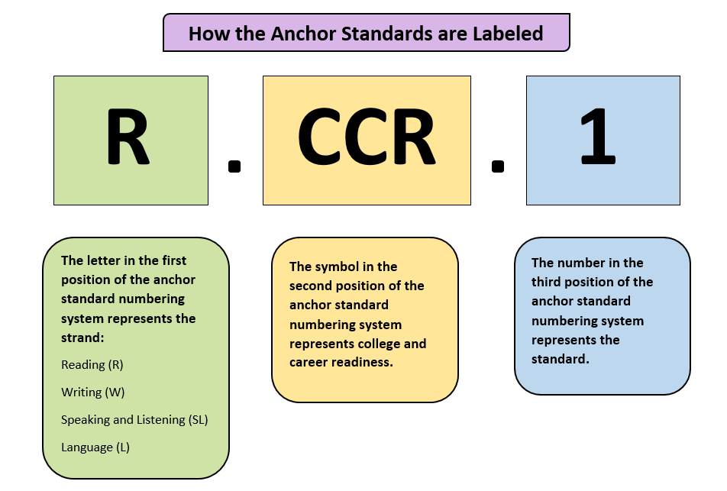
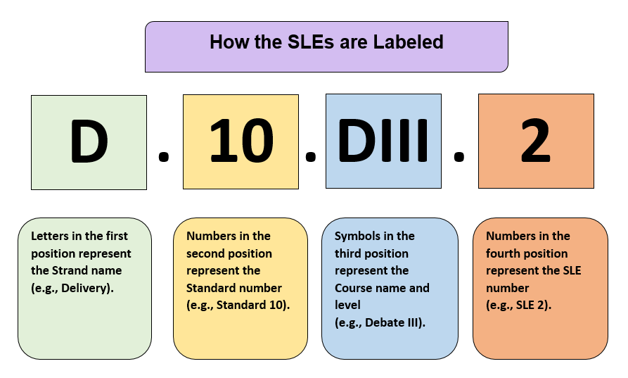
Strand: Oral Interpretation
Content Standard 1: Students will demonstrate mastery competency through a variety of literary performances.

AR ELA Alignment
OI.1.FIV.1 | Select and analyze specific genres of literature to find appropriate stories (e.g., adventure, biographical story, children’s stories, fairy tale, fantasy, historical accounts, modern short story, mythology) | R.CCR.1, R.CCR.2, R.CCR.3, R.CCR.4, R.CCR.5, R.CCR.6, R.CCR.7, R.CCR.8, R.CCR.9, R.CCR.10
OI.1.FIV.2 | Demonstrate at a mastery level how vocal variety alters characterization | SL.CCR.6
OI.1.FIV.3 | Analyze and incorporate, into a performance, the important elements of a story or poem | R.CCR.1, R.CCR.2, R.CCR.3, R.CCR.5
OI.1.FIV.4 | Analyze and incorporate the role of movement and gesture in performing oral readings
OI.1.FIV.5 | Generate appropriate movement for performances at a mastery level:  - heightened movement  - movement to delineate character, time, place, and/or mood  - simplified movement
OI.1.FIV.6 | Master the use of paralanguage in performances to match emotion:  - dramatic pause  - inflection  - oral punctuation  - pitch variation  - stress  - tempo  - volume | SL.CCR.6, L.CCR.1, L.CCR.3
OI.1.FIV.7 | Master correct pronunciation and inflection (e.g., acceptance, education, limitations, locale, regional similarity) | SL.CCR.6
OI.1.FIV.8 | Synthesize oral interpretation with content and intent | SL.CCR.3, SL.CCR.4, SL.CCR.6
OI.1.FIV.9 | Compile and maintain a portfolio for oral interpretation:  - culturally diverse literature  - dramatic literature  - humorous literature  - poetry  - prose  - social issues | R.CCR.10
OI.1.FIV.10 | Select literature to be performed based on selected criteria | R.CCR.10
OI.1.FIV.11 | Conduct an audience analysis | SL.CCR.4, SL.CCR.6
OI.1.FIV.12 | Analyze character complexity to develop a fully actualized performance | R.CCR.3
OI.1.FIV.13 | Examine the historical impact of literature selected for oral interpretation to develop a fully actualized performance | R.CCR.3, R.CCR.6, R.CCR.10
OI.1.FIV.14 | Determine appropriate volume for diverse audiences or venues | SL.CCR.6
OI.1.FIV.15 | Experiment and perfect various introductory methods (e.g., author biography, excerpt/exposition, humor, narrative, related anecdote, startling statement, teasers) | SL.CCR.4, SLCCR.6
OI.1.FIV.16 | Direct a group presentation (e.g., Choral Reading, Readers Theater) | SL.CCR.6
OI.1.FIV.17 | Serve as a mentor for students in Forensics I-III | SL.CCR.6
OI.1.FIV.18 | Lead group evaluations | SL.CCR.1, SL.CCR.2, SL.CCR.3, L.CCR.1, L.CCR.3
OI.1.FIV.19 | Examine and develop the social impact of a literary selection for a fully actualized performance at a mastery level | R.CCR.1, R.CCR.2, R.CCR.3, R.CCR.4, R.CCR.5, R.CCR.6, R.CCR.7, R.CCR.8, R.CCR.9, R.CCR.10, SL.CCR.6
OI.1.FIV.20 | Score a script
OI.1.FIV.21 | Compare multiple interpretations of a selection to develop a fully actualized performance at a mastery level | R.CCR.6, R.CCR.9, R.CCR.10, SL.CCR.6
OI.1.FIV.22 | Compare first- and third- person point-of-view | R.CCR.6
OI.1.FIV.23 | Contrast performances of fiction and nonfiction to develop a fully actualized performance at a mastery level | R.CCR.7, R.CCR.9, SL.CCR.3
OI.1.FIV.24 | Incorporate chosen feedback into future presentations or performances:  - peer ballots and rubric  - teacher/evaluator ballots and rubrics | SL.CCR.4, SL.CCR.5, SL.CCR.6
OI.1.FIV.25 | Accept and analyze appropriate feedback from critiques | SL.CCR.3, SL.CCR.6

Strand: Performance Literature
Content Standard 2: Students will demonstrate competency in a variety of genres.

AR ELA Alignment
PL.2.FIV.1 | Compare and analyze performance literature for specific settings to develop a fully actualized performance at a mastery level | SL.CCR.3
PL.2.FIV.2 | Examine the theme of the literature | R.CCR.2
PL.2.FIV.3 | Analyze the imagery within the literature to develop a fully actualized performance at a mastery level | R.CCR.4
PL.2.FIV.4 | Prepare performance cuttings at a mastery level (e.g., monologue, duet, words and music, humorous interpretation, dramatic interpretation, program oral interpretation) | SL.CCR.4, SL.CCR.6
PL.2.FIV.5 | Cut a piece of literature down to a specified time limit | SL.CCR.6

L.2.FIV.6 | Apply stage direction terminology to personal and group performances at a mastery level:  - above  - backstage  - below  - blocking  - breaking character  - counter cross  - downstage  - fluidity  - full back  - full front  - give a scene  - in the moment  - levels  - motivation  - offstage  - onstage  - profile  - share a scene  - stage left  - stage right  - tagging lines  - take a scene  - three-quarter  - timing  - topping lines  - upstage  - wings | L.CCR.6
PL.2.FIV.7 | Block a personal performance and defend choices at a mastery level
PL.2.FIV.8 | Analyze pivotal moments in performance literature | R.CCR.5

PL.2.FIV.9 | Develop a mastery understanding of basic competitive events adhering to national set performance criteria provided through the National Speech and Debate Association:  - dramatic interpretation  - duo interpretation  - extemporaneous speaking  - humorous interpretation  - improvised duet acting  - informative speaking  - original oratory  - poetry  - program oral interpretation  - prose  - storytelling
PL.2.FIV.10 | Perform selections for audiences outside the classroom (e.g., civic organizations, classroom showcases of performance work, community events, elementary school classroom performances, parent nights, school assemblies) | SL.CCR.6
PL.2.FIV.11 | Research the historical context of performance literature to develop a fully actualized performance at a mastery level | W.CCR.7
PL.2.FIV.12 | Investigate the playwright’s intended meaning to develop a fully actualized performance at a mastery level | R.CCR.1, R.CCR.2, R.CCR.3, R.CCR.4, R.CCR.5, R.CRR.6, R.CCR.8
PL.2.FIV.13 | Examine the social impact of the play or scene to develop a fully actualized performance at a mastery level | R.CCR.5, W.CCR.7, W.CCR.9
PL.2.FIV.14 | Research culturally diverse performance literature to develop a fully actualized performance at a mastery level | W.CCR.7, W.CCR.8, W.CCR.9, W.CCR.10
PL.2.FIV.15 | Delineate characters using various techniques to develop a fully actualized performance at a mastery level (e.g., body posture, consistent mannerisms, large gestures, nonverbal facial expressions,  vocal delivery) | SL.CCR.6
PL.2.FIV.16 | Evaluate cutting from literature to determine its ability to stand alone as a performance piece to develop a fully actualized performance at a mastery level (e.g., beginning and end, complications that build, self-contained events) | R.CCR.1, R.CCR.2, R.CCR.5

PL.2.FIV.17 | Incorporate chosen feedback into future presentations or performances at a mastery level:  - peer ballots and rubrics  - teacher/evaluator ballots and rubrics | SL.CCR.6
PL.2.FIV.18 | Accept and analyze appropriate feedback from critiques | SL.CCR.6
PL.2.FIV.19 | Analyze how characters evolve throughout a performance to develop a fully actualized performance at a mastery level | R.CCR.3
PL.2.FIV.20 | Create introductions that capture the audience (e.g., dramatic, intriguing, shocking, tantalizing, unique) | SL.CCR.6, L.CCR.1, L.CCR.3
PL.2.FIV.21 | Discuss motivation as it relates to dialogue | SL.CCR.1, L.CCR.1, L.CCR.3

Strand: Public Speaking
Content Standard 3: Students will synthesize information to create a variety of speaking genres.

AR ELA Alignment
PS.3.FIV.1 | Develop a mastery understanding of public speaking rules to create an effective presentation:  - competition events  - extemporaneous speaking  - informative speaking  - original oratory (persuasive speaking) | W.CCR.9
PS.3.FIV.2 | Examine and defend source credibility in personal presentations at a mastery level | W.CCR.7, W.CCR.8, W.CCR.9, SL.CCR.1, SL.CCR.3, SL.CCR.6
PS.3.FIV.3 | Summarize complex ideas by accurately paraphrasing | R.CCR.2, L.CCR.1, L.CCR.3, L.CCR.6
PS.3.FIV.4 | Examine criteria for speech topics at a mastery level (e.g., age appropriateness, creative angle, interesting to both genders, personal connection, sound documentation, speech type, uniqueness, universal appeal) | R.CCR.10
PS.3.FIV.5 | Integrate feedback received after speeches to increase effectiveness of the speaker’s delivery | SL.CCR.6
PS.3.FIV.6 | Integrate feedback received after speeches to refine use of various levels of intensity as appropriate for task, purpose, and audience | SL.CCR.6
PS.3.FIV.7 | Integrate feedback received after speeches to use appropriate tone in delivery | SL.CCR.6
PS.3.FIV.8 | Integrate feedback received after speeches to adjust the pace of delivery | SL.CCR.6
PS.3.FIV.9 | Utilize transitions as strategic connections | L.CCR.3
PS.3.FIV.10 | Defend selected methods of reasoning | R.CCR.10
PS.3.FIV.11 | Question author biases or prejudices in informational texts | R.CCR.6, L.CCR.1, L.CCR.3
PS.3.FIV.12 | Identify the role of ethics in debate and/or argumentation | R.CCR.6
PS.3.FIV.13 | Analyze the effectiveness of presentations conducted by oneself and peers and synthesize the feedback to create a more polished presentation | SL.CCR.3
PS.3.FIV.14 | Formulate and design a properly worded proposition of fact, value, and policy | SL.CCR.4, SL.CCR.6, L.CCR.1, L.CCR.3
PS.3.FIV.15 | Demonstrate the different kinds of argumentation at a mastery level (e.g., argument by generalization, argument from analogy, argument from authority, argument from expertise, argument from precedent, argument from sign, causal argument, causal chain of reasoning) | R.CCR.8, W.CCR.9, SL.CCR.4, SL.CCR.5, SL.CCR.6, L.CCR.1, L.CCR.3
PS.3.FIV.16 | Construct arguments to support a claim | W.CCR.1, SL.CCR.4, SL.CCR.5, SL.CCR.6, L.CCR.1, L.CCR.3
PS.3.FIV.17 | Demonstrate knowledge of the guidelines for ethics in research | W.CCR.8
PS.3.FIV.18 | Implement various persuasive, informative, and extemporaneous formats at a mastery level | R.CCR.8, W.CCR.7, W.CCR.8, W.CCR.9, SL.CCR.3, SL.CCR.6, L.CCR.1, L.CCR.3
PS.3.FIV.19 | Use evidence to develop stronger arguments at a mastery level | W.CCR.1, W.CCR.4, W.CCR.5, W.CCR.6, W.CCR.7, W.CCR.8, W.CCR.9, W.CCR.10, L.CCR.1, L.CCR.3
PS.3.FIV.20 | Draw conclusions that are defensible | R.CCR.1, R.CCR.2, R.CCR.3, R.CCR.4, R.CCR.5, R.CCR.8, R.CCR.9, SL.CCR.2, SL.CCR.3
PS.3.FIV.21 | Practice the process of inquiry in the following order:  - examine data  - ask questions based on data  - re-examine data  - try to answer the questions  - data that supports our answer = evidence | R.CCR.1, R.CCR.2, R.CCR.7, R.CCR.8, R.CCR.9, W.CCR.7, W.CCR.8, W.CCR.9, L.CCR.1, L.CCR.3

PS.3.FIV.22 | Strengthen an understanding of the structure and format of each public speech to create an effective presentation at a mastery level:  - extemporaneous speaking  - informative speaking (visual aids)  - original oratory | R.CCR.5
PS.3.FIV.23 | Formulate questions and analyze current, domestic, and foreign events to create an effective presentation at a mastery level | W.CCR.7, W.CCR.8, W.CCR.9, W.CCR.10, L.CCR.1, L.CCR.3
PS.3.FIV.24 | Determine the magnitude of a current event topic to create an effective presentation at a mastery level | W.CCR.7, W.CCR.8, W.CCR.9, W.CCR.10
PS.3.FIV.25 | Discuss the differences among statements of fact, value, and policy and use each to create effective presentations at mastery level | SL.CCR.1, SL.CCR.3, SL.CCR.6
PS.3.FIV.26 | Contrast the types of reasoning to create an effective presentation at a mastery level:  - analogy  - causal  - deductive  - inductive | R.CCR.8
PS.3.FIV.27 | Investigate current issues of controversy to create an effective presentation at a mastery level | W.CCR.7, W.CCR.8, W.CCR.9
PS.3.FIV.28 | Synthesize information from research using scientific and technical texts, scholarly journals, and different media formats | R.CCR.7, W.CCR.8, W.CCR.9, SL.CCR.2, SL.CCR.5
PS.3.FIV.29 | Evaluate credibility of sources | W.CCR.8
PS.3.FIV.30 | Cite sources accurately and appropriately | W.CCR.8

Strand: Mastery Communication Skills
Content Standard 4: Students will demonstrate communication skills at a mastery level.

AR ELA Alignment
MCS.4.FIV.1 | Demonstrate the use of varied sentence structure to create emphasis | W.CCR.4, W.CCR.5, SL.CCR.4, SL.CCR.6, L.CCR.3
MCS.4.FIV.2 | Work collaboratively to generate ideas and solve complex problems | W.CCR.6, SL.CCR.1, SL.CCR.6, L.CCR.1, L.CCR.3
MCS.4.FIV.3 | Participate in discussions for varied purposes | SL.CCR.1, SL.CCR.6
MCS.4.FIV.4 | Use vocal variety to establish mood, feelings, and attitude | SL.CCR.6
MCS.4.FIV.5 | Control breathing to increase volume and resonance:  - diaphragmatic breathing  - timing of inhalation and exhalation | SL.CCR.6
MCS.4.FIV.6 | Demonstrate appropriate articulation:  - dialect  - enunciation  - pronunciation | SL.CCR.6
MCS.4.FIV.7 | Demonstrate audible speech/vocal flexibility | SL.CCR.6
MCS.4.FIV.8 | Demonstrate fluency at the mastery level | SL.CCR.4, SL.CCR.6
MCS.4.FIV.9 | Display appropriate social etiquette | SL.CCR.4, SL.CCR.6
MCS.4.FIV.10 | Demonstrate vocal projection to a specific target | SL.CCR.6
MCS.4.FIV.11 | Adjust vocal projection based on the following:  - level of noise in environment  - size of audience  - size of room | SL.CCR.6
MCS.4.FIV.12 | Evaluate information from a variety of sources | R.CCR.7, R.CCR.8, R.CCR.9, R.CCR.10, W.CCR.7, W.CCR.8, W.CCR.9, SL.CCR.2

Strand: Oral Advocacy
Content Standard 5: Students will participate at the mastery level in community outreach, culminating in events.

AR ELA Alignment
OA.5.FIV.1 | Demonstrate mastery of terminology and execution of a competitive event | L.CCR.6
OA.5.FIV.2 | Execute the duties and needs assigned by event directors and document the process to secure event resources (e.g., judges, concessions, security, hospitality, time keepers, public relations, volunteers as needed)
OA.5.FIV.3 | Solicit the community for needed resources and materials to support events | W.CCR.2
Teacher Note

OA.5.FIV.3
Students document their process to find needed resources and materials.

OA.5.FIV.4 | Apply effective leadership skills when collaborating with peers | SL.CCR.6
OA.5.FIV.5 | Research the qualities of a strong leader | W.CCR.7
OA.5.FIV.6 | Apply conflict resolution strategies when collaborating with peers | SL.CCR.6
OA.5.FIV.7 | Explore how to separate valuable feedback from differing opinions and incorporate into interactions | SL.CCR.6
OA.5.FIV.8 | Discuss and document successes and challenges when reflecting on a completed event to inform future planning and implementation | W.CCR.6, SL.CCR.1

Strand: Peer Directing and Critiquing
Content Standard 6: Students will demonstrate mastery of independent peer directing and peer evaluation skills.

AR ELA Alignment
PDC.6.FIV.1 | Explore the duties of a director | W.CCR.7, SL.CCR.1
PDC.6.FIV.2 | Incorporate instructor feedback into an original script prior to production | W.CCR.5
PDC.6.FIV.3 | Develop an understanding of how to work with actors to elicit stellar performances
PDC.6.FIV.4 | Create an effective scene with a strong beginning, middle and end | W.CCR.3, W.CCR.4, W.CCR.5, W.CCR.6, W.CCR.10, L.CCR.3
PDC.6.FIV.5 | Communicate intention, physicality, and motivation of a character within the scene | W.CCR.4, SL.CCR.4, SL.CCR.6
PDC.6.FIV.6 | Determine the meaning of literature for direction purposes | R.CCR.1, R.CCR.3, R.CCR.4, R.CCR.5, R.CCR.6
PDC.6.FIV.7 | Determine author’s intent as it applies to blocking, movement and aesthetics for directing a performance | R.CCR.6
PDC.6.FIV.8 | Analyze characters to apply blocking, movement, and aesthetics as the director of a performance | R.CCR.3
PDC.6.FIV.9 | Define and incorporate technical language as it applies to directing a performance | L.CCR.6
PDC.6.FIV.10 | Select plays and musicals with literary merit for directing purposes | R.CCR.10
PDC.6.FIV.11 | Compile and compose Readers Theater scripts with literary merit for direction purposes | R.CCR.10
PDC.6.FIV.12 | Analyze the mood of a selection from beginning to end for directing purposes | R.CCR.1, R.CCR.4, R.CCR.5, R.CCR.6
PDC.6.FIV.13 | Devise a directorial philosophy based on historical context and cultural influences | W.CCR.2, W.CCR.4, W.CCR.6, W.CCR.9, W.CCR.10, L.CCR.1, L.CCR.2, L.CCR.3, R.CCR.6

PDC.6.FIV.14 | Maintain a director’s portfolio | W.CCR.6, W.CCR.10
PDC.6.FIV.15 | Devise a directorial philosophy based on current and political events | W.CCR.2, W.CCR.4, W.CCR.6, W.CCR.9, W.CCR.10, L.CCR.1, L.CCR.2, L.CCR.3, R.CCR.6
PDC.6.FIV.16 | Synthesize information from research using scientific and technical texts, scholarly journals and different media formats as it applies to directing choices | W.CCR.7, W.CCR.8, W.CCR.9
PDC.6.FIV.17 | Research various sources of licensing agents for directing scripts, plays, and musicals | W.CCR.7
PDC.6.FIV.18 | Create a production staff that will collect and analyze researched materials for the purpose of authenticity of plays and musicals
PDC.6.FIV.19 | Conduct audience-centered analysis for production purposes | R.CCR.10
PDC.6.FIV.20 | Cut a literary selection effectively for directing plays, musicals, and Readers Theaters | R.CCR.10
PDC.6.FIV.21 | Direct performances that have been thoroughly analyzed | SL.CCR.6
PDC.6.FIV.22 | Paraphrase directorial objectives to actors and technical crew | SL.CCR.6
PDC.6.FIV.23 | Create effective transitions from scene to scene or from musical number to scene | W.CCR.4
PDC.6.FIV.24 | Execute proper citation of licensing agents | W.CCR.8
PDC.6.FIV.25 | Modify direction based on critical feedback from instructor | SL.CCR.6
PDC.6.FIV.26 | Defend character motivation as it applies to directing | SL.CCR.4, SL.CCR.6
PDC.6.FIV.27 | Write a director’s rationale for one play, one musical, and one Readers Theater | W.CCR.1, W.CCR.4, W.CCR.8, W.CCR.9, W.CCR.10
PDC.6.FIV.28 | Interpret point of view to find meaning of a selection as it applies to a play, musical or Readers Theater script | R.CCR.6
PDC.6.FIV.29 | Interpret imagery through direction using author’s context clues | R.CCR.1, R.CCR.4

PDC.6.FIV.30 | Evaluate author’s intents and how it relates to director’s vision | R.CCR.6
PDC.6.FIV.31 | Critique peer performances using the Arkansas Communication and Theater Arts Association performance rubrics | SL.CCR.6
PDC.6.FIV.32 | Master directorial methods:  - defend a point of view by writing a director’s rationale  - direct actors on how to master appropriate movement for performance  - direct actors on proper usage of verbal emphasis  - direct actors on the effective use of pauses to vary tempo and match emotion  - direct actors to create intensity with varied vocal inflection  - direct actors to master clear articulation | SL.CCR.6
PDC.6.FIV.33 | Organize a director’s post-performance assessment discussion | SL.CCR.1, SL.CCR.4, SL.CCR.6

Glossary for Forensics IV

Academic honesty | Performing all academic work in a responsible and ethical manner, which includes acknowledging any source of information that is not common knowledge and completing academic work without cheating, lying, stealing, or sharing information without authorization
Ad hominem | A Latin term meaning “to the man”
Ad populum | A Latin term meaning “to the popular opinion”
Arkansas Communication and Theater Arts Association (ACTAA) | State professional organization that encompasses theater, drama, theater dance, oral communication, forensics, and debate
Diversity | Understanding that each individual is unique and recognizing individual differences  (e.g., ability, culture, federally protected categories, gender, race, religion, socio-economic status)
Literary merit | The quality shared by all works of fiction that are considered to have aesthetic value
National Speech and Debate Association (NSDA) | National professional organization for debate, speech, and forensics
Paralanguage | Nonverbal means of communication  (e.g., tone of voice, laughter, gestures, facial expressions) that accompany speech and convey further meaning
Post hoc ergo propter hoc | A Latin term meaning “after the fact, therefore before the fact”; this is a conclusion that assumes if “A” occurred after “B”, then “B” must have caused “A”
Proxemics | Communicating with others by virtue of the relative positioning of the body
Reticence | The trait of being uncommunicative; not volunteering anything more than necessary
Semantics | The study of the meanings of words

Contributors

The following people contributed to the development of this document:

Jennifer Akers - Cabot | Amy Matthews - Fayetteville
Tammy Alexander - Nashville | Gerri McCann - Manila
Rebecca Allen - Valley View | Amanda McMahan - Magnolia
Jane Balgavy - Jacksonville-North Pulaski | Lynn Meade - University of Arkansas
Brandon Box-Higdem - Bentonville | Alisa Melton - Blytheville
Samantha Carpenter - Virtual Arkansas | Jennifer Murphy - El Dorado
Lisa Carver - Texarkana | Traci Myers - Foreman
Kimberly Chavez - Camden Fairview | Tim Peerbolte - Greenwood
Susan Colyer - Fort Smith | Erin Radke - Jessieville
Joan Crowder - Arkadelphia | Jacki Reiff - Gravette
April Erickson - South Conway County | Tracie Richard - Hermitage
Jessica Foster - Siloam Springs | Chad Simpson - Clarendon
Sommer Frazer - McGehee | Dallas Sims - Lakeside (Lake Village)
Natalie Free - Pangburn | Vivian Sisk – KIPP: Delta Collegiate
Eric Gamble - Dardanelle | Andrea Speer - Bentonville
Jennifer Garner - Lakeside (Hot Springs) | Steven Trulock - Huntsville
Roger Guevara - Southern Arkansas University | Rosie Valdez - Little Rock
Shelly Hardin - West Memphis

