Journalism IV
Arkansas
English Language Arts Standards
2016

Course Title: Journalism IV
Course/Unit Credit: 1
Course Number: 415030
Teacher Licensure: Please refer to the Course Code Management System (https://adedata.arkansas.gov/ccms/) for the most current licensure codes.
Grades: 9-12
Prerequisites: Journalism I, II, and III

Journalism IV

Journalism III is a prerequisite for Journalism IV. Students entering Journalism II, III, or IV must have successfully completed the preceding year of study. Journalism I is a foundational course and cannot be combined with other courses. Journalism II-IV may be taught within the same class period; however, the student learning expectations for each level are different and must be addressed.

Journalism IV is designed to provide students in media leadership the opportunity to facilitate the production process. Students in Journalism IV will use their advanced journalistic knowledge and leadership skills to facilitate all aspects of media production and to ensure that journalistic guidelines for writing and design, which include objectivity, responsibility, and credibility, are followed. Writing, technology, and visual and electronic media are used as tools for learning as students lead, create, evaluate, and produce.

Journalism I, II, III, and IV do not require Arkansas Department of Education approval.

Strand Content Standard
Law and Ethics
- Students will evaluate legal and ethical issues.
History
- Students will demonstrate a working knowledge of the history and role of journalism in society.
Management and Organization
- Students will demonstrate a working knowledge of staff management and organization.
Design
- Students will create designs for media.
Writing
- Students will create various pieces of journalistically sound writing.
Photography
- Students will demonstrate a working knowledge of photographic principles.
Publishing
- Students will publish journalistically sound media.

Notes:
- Each level continues to address earlier Student Learning Expectations (SLEs) as needed.
- Student Learning Expectations (SLEs) may be taught in any sequence.
- Italicized words in this document appear in the glossary.
- All items in a bulleted list are required to be taught.
- The examples given (e.g.,) are suggestions to guide the instructor.
- Publishing can include, but is not limited to, school publications (e.g., yearbook, newspaper, literary magazine, online media) and community media.

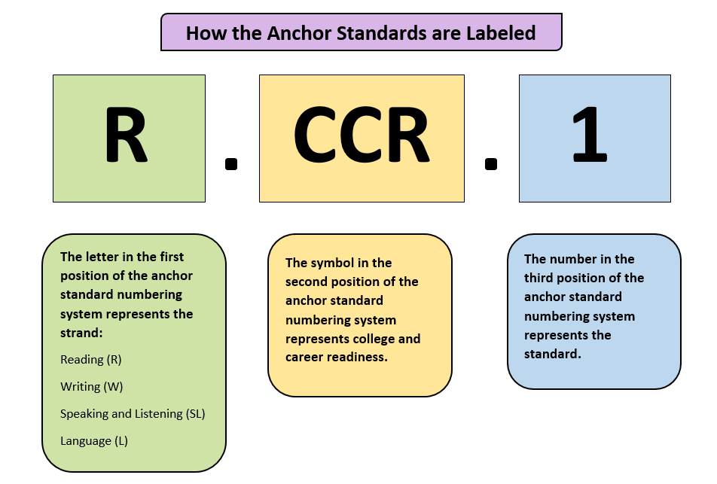
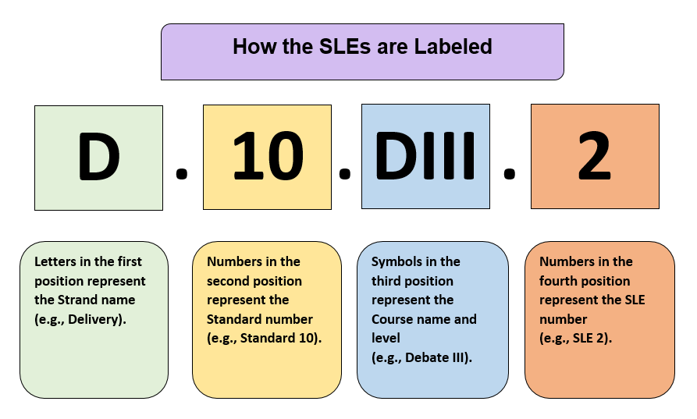

Strand: Law and Ethics
Content Standard 1: Students will evaluate legal and ethical issues.

AR ELA Alignment
LE.1.JIV.1 | Create legal and ethical policies for student media | W.CCR.2, W.CCR.4, W.CCR.5, W.CCR.6,  W.CCR.7, W.CCR.8,  W.CCR.9, SL.CCR.4, SL.CCR.5, SL.CCR.6, L.CCR.1, L.CCR.2, L.CCR.6
LE.1.JIV.2 | Create policies for electronic student media | W.CCR.2, W.CCR.4, W.CCR.5, W.CCR.6,  W.CCR.7, W.CCR.8,  W.CCR.9, SL.CCR.4, SL.CCR.5, SL.CCR.6, L.CCR.1, L.CCR.2, L.CCR.6
LE.1.JIV.3 | Evaluate ethical responsibilities for student media | R.CCR.1, R.CCR.2, R.CCR.3, R.CCR.4, R.CCR.5, R.CCR.6, R.CCR.7, R.CCR.8, R.CCR.10, L.CCR.1, L.CCR.2, L.CCR.3, L.CCR.4, L.CCR.5, L.CCR.6
LE.1.JIV.4 | Evaluate ethical responsibilities regarding technological aspects of student media | R.CCR.1, R.CCR.2, R.CCR.3, R.CCR.4, R.CCR.5, R.CCR.6, R.CCR.7, R.CCR.8, R.CCR.10, L.CCR.1, L.CCR.2, L.CCR.3, L.CCR.4, L.CCR.5, L.CCR.6

Strand: History
Content Standard 2: Students will demonstrate a working knowledge of the history and role of journalism in society.

AR ELA Alignment
H.2.JIV.1 | Evaluate current events in a democratic society | R.CCR.1, R.CCR.2, R.CCR.3, R.CCR.4, R.CCR.5, R.CCR.6, R.CCR.7, R.CCR.8, R.CCR.10, L.CCR.1, L.CCR.2, L.CCR.3, L.CCR.4, L.CCR.5, L.CCR.6
H.2.JIV.2 | Integrate concepts from current events in contemporary journalism to established student media | R.CCR.7, R.CCR.8, R.CCR.9, R.CCR.10, W.CCR.2, W.CCR.7, W.CCR.8, W.CCR.9, W.CCR.10
H.2.JIV.3 | Evaluate photography in contemporary journalism (e.g., emotional connection, how photos enhance text, reader response, storytelling quality of the photo) | R.CCR.7, W.CCR.9

Strand: Management and Organization
Content Standard 3: Students will demonstrate a working knowledge of staff management and organization.

AR ELA Alignment
MO.3.JIV.1 | Create staff organizational and time management strategies necessary to meet student media production schedules | W.CCR.6
MO.3.JIV.2 | Create staff plan for financing student media | W.CCR.6
MO.3.JIV.3 | Create staff plan to maximize the circulation of student media | W.CCR.6
MO.3.JIV.4 | This standard is taught in Journalism I and should be reinforced as needed.  Investigate careers in journalism

Strand: Design
Content Standard 4: Students will create designs for media.

AR ELA Alignment
D.4.JIV.1 | Evaluate designs created for media | R.CCR.7, W.CCR.6,  SL.CCR.2, SL.CCR.6, L.CCR.1, L.CCR.2, L.CCR.3
D.4.JIV.2 | Create advanced designs for media | W.CCR.6, SL.CCR.5
D.4.JIV.3 | Create designs that incorporate trends in media | W.CCR.6, SL.CCR.5

Strand: Writing
Content Standard 5: Students will create various pieces of journalistically sound writing.

AR ELA Alignment
W.5.JIV.1 | Evaluate original interview questions using advanced research skills for various forms of writing | R.CCR.1, R.CCR.4, R.CCR.6, L.CCR.1, L.CCR.2, L.CCR.6
W.5.JIV.2 | Analyze interviews for relevance to media | W.CCR.6, SL.CCR.2
W.5.JIV.3 | Evaluate information for relevance, accuracy, and completeness of information from multiple sources | R.CCR.8, W.CCR.8
W.5.JIV.4 | Evaluate leads for appropriateness | W.CCR.4, W.CCR.5, W.CCR.6, W.CCR.10,  L.CCR.1, L.CCR.2,  L.CCR.3
W.5.JIV.5 | Evaluate the relevance and application of fundamental questions of journalism in a news story | W.CCR.4, W.CCR.5,  W.CCR.6, W.CCR.7
W.5.JIV.6 | Evaluate the relevance and application of news elements in copy | W.CCR.4, W.CCR.5,  W.CCR.6, W.CCR.7
W.5.JIV.7 | Evaluate relevance and application of direct and indirect quotes in copy | W.CCR.8, W.CCR.9, W.CCR.10

Strand: Writing
Content Standard 5: Students will create various pieces of journalistically sound writing.

AR ELA Alignment
W.5.JIV.8 | Evaluate various forms of journalistically sound writing for suitable relevance, accuracy, and completeness of information | R.CCR.1, R.CCR.2, R.CCR.2, R.CCR.4, R.CCR.5, R.CCR.6, R.CCR.7, R.CCR.8, R.CCR.9, R.CCR.10, SL.CCR.1, SL.CCR.3, L.CCR.1, L.CCR.2, L.CCR.3
W.5.JIV.9 | Edit various forms of writing  - peer edit  - self-edit | W.CCR.5, L.CCR.1, L.CCR.2, L.CCR.3
W.5.JIV.10 | Revise original pieces for content and style | W.CCR.5, L.CCR.1, L.CCR.2, L.CCR.3
W.5.JIV.11 | Analyze and organize content for student media | W.CCR.4, W.CCR.6, W.CCR.10, L.CCR.1, L.CCR.2, L.CCR.3
W.5.JIV.12 | Evaluate captions for journalistic style | W.CCR.4, W.CCR.6, W.CCR.10, L.CCR.1, L.CCR.2, L.CCR.3
W.5.JIV.13 | Evaluate headlines for journalistic style | W.CCR.4, W.CCR.6, W.CCR.10, L.CCR.1, L.CCR.2, L.CCR.3

Strand: Photography
Content Standard 6: Students will demonstrate a working knowledge of photographic principles.

AR ELA Alignment
PH.6.JIV.1 | Edit and integrate photographic pieces into media | R.CCR.7
PH.6.JIV.2 | Apply use of camera controls, lenses, and equipment as needed in student media
PH.6.JIV.3 | This standard is taught in Journalism II and should be reinforced as needed.  Analyze the use of composition skills of photography (e.g., angle, dominant element, leading lines, rule of thirds, selective focus)
PH.6.JIV.4 | Edit visual pieces for photographic composition in media
PH.6.JIV.5 | Integrate photojournalism in media (e.g., convergent media, videos, vlogs) | W.CCR.8

Strand: Publishing
Content Standard 7: Students will publish journalistically sound media.

AR ELA Alignment
P.7.JIV.1 | This standard is taught in Journalism I and should be reinforced as needed.  Describe forms of publishing (e.g., newspaper, yearbook, literary magazine, Web, social media)
P.7.JIV.2 | Evaluate and integrate content for media through reporting, writing, editing, photography, layout, and design | W.CCR.4, W.CCR.5, W.CCR.6, W.CCR.7, W.CCR.8, W.CCR.9,  SL.CCR.3, SL.CCR.4, SL.CCR.5, SL.CCR.6, L.CCR.1, L.CCR.2, L.CCR.3, L.CCR.6
P.7.JIV.3 | Publish a variety of original journalistically sound pieces | W.CCR.1, W.CCR.2, W.CCR.3, W.CCR.4, W.CCR.5, W.CCR.6, W.CCR.7, W.CCR.8, W.CCR.9, W.CCR.10,  SL.CCR.4, SL.CCR.5, SL.CCR.6, L.CCR.1, L.CCR.2, L.CCR.3, L.CCR.5, L.CCR.6

Glossary for Journalism IV

Convergent media | Multiple media that combines to form one product
Journalistically sound | Adheres to the journalistic guidelines for writing and design based on objectivity, responsibility, and credibility
Journalistic style | Style that is determined by journalism organizations in order to maintain consistency in media (e.g., Associated Press, student press organizations)
Vlogs | Video log embedded in online media

Contributors

The following people contributed to the development of this document:

Jennifer Akers - Cabot | Amy Matthews - Fayetteville
Tammy Alexander - Nashville | Gerri McCann - Manila
Rebecca Allen - Valley View | Amanda McMahan - Magnolia
Jane Balgavy - Jacksonville-North Pulaski | Lynn Meade - University of Arkansas
Brandon Box-Higdem - Bentonville | Alisa Melton - Blytheville
Samantha Carpenter - Virtual Arkansas | Jennifer Murphy - El Dorado
Lisa Carver - Texarkana | Traci Myers - Foreman
Kimberly Chavez - Camden Fairview | Tim Peerbolte - Greenwood
Susan Colyer - Fort Smith | Erin Radke - Jessieville
Joan Crowder - Arkadelphia | Jacki Reiff - Gravette
April Erickson - South Conway County | Tracie Richard - Hermitage
Jessica Foster - Siloam Springs | Chad Simpson - Clarendon
Sommer Frazer - McGehee | Dallas Sims - Lakeside (Lake Village)
Natalie Free - Pangburn | Vivian Sisk – KIPP: Delta Collegiate
Eric Gamble - Dardanelle | Andrea Speer - Bentonville
Jennifer Garner - Lakeside (Hot Springs) | Steven Trulock - Huntsville
Roger Guevara - Southern Arkansas University | Rosie Valdez - Little Rock
Shelly Hardin - West Memphis

