Strategic Reading

Arkansas
English Language Arts Standards
2016

Course Title: Strategic Reading
Course/Unit Credit:
Course Number: 358140
Teacher Licensure: Please refer to the Course Code Management System (https://adedata.arkansas.gov/ccms/) for the most current licensure codes.
Grades: 6-8

Strategic Reading

Strategic Reading is a two-semester course designed to dramatically accelerate reading growth by strengthening comprehension outcomes in middle level grades. In a context of meaningful content, on-going assessment, and focused explicit instruction, students will synthesize literary and informational texts and multicultural literature of diverse formats (e.g., print media, Web-based texts, literary and informational books and articles) and genres. In addition, students will engage in learning events tied to a variety of literary and informational texts with increasing complexity. Additionally, students will demonstrate literacy competence through purposeful application of knowledge and skills from this course, based on individual and collective literacy goals. Strategic Reading does not require Arkansas Department of Education approval.

Strand Content Standard
Engaging the Reader
1. Students will become self-directed readers through exposure to various genres and media by engaging in literacy experiences relevant to personal interests, goals, everyday life, or world events.

Comprehension Strategies
2. Students will use a variety of strategies to comprehend literary and informational texts.

Response to Text
3. Students will respond to a variety of texts through writing and extended discussion.
Vocabulary Development
4. Students will increase vocabulary knowledge through multiple word study and decoding strategies to gain meaning of new words in a variety of contexts.

Notes:
- Student Learning Expectations (SLEs) may be taught in any sequence.
- Italicized words in this document appear in the glossary.
- All items in a bulleted list are required to be taught.
- The examples given (e.g.,) are suggestions to guide the instructor.

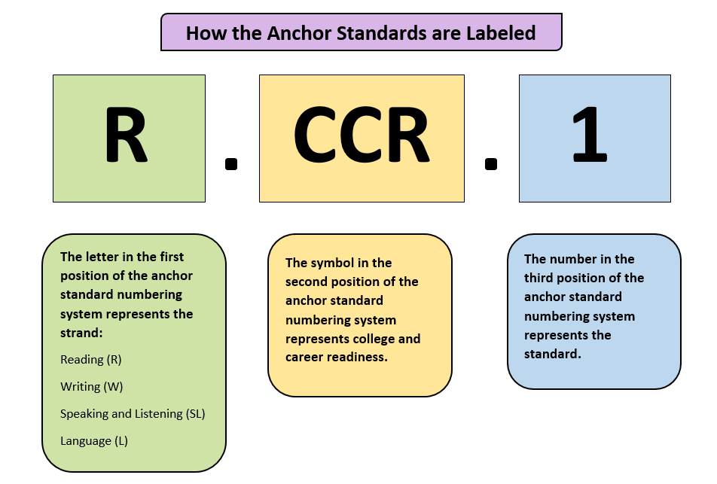
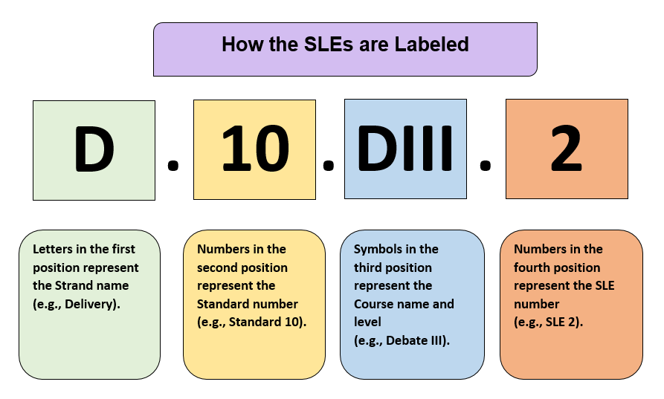
Strand: Engaging the Reader
Content Standard 1: Students will become self-directed readers through exposure to various genres and media by engaging in literacy
experiences relevant to personal interests, goals, everyday life, or world events.

AR ELA Alignment
ER.1.SR.1 | Analyze personal literary interests by exploring and tracking reading preferences (e.g., peer and teacher reading conferences, reading logs, learning logs, surveys, self-assessments, personal interest inventories) | W.CCR.2, W.CCR.4, W.CCR.6, W.CCR.7, W.CCR.10, SL.CCR.1, SL.CCR.2, SL.CCR.4, SL.CCR.5, SL.CCR.6, L.CCR.1, L.CCR.2, L.CCR.3, L.CCR.6
ER.1.SR.2 | Develop and refine personal learning goals | SL.CCR.1, SL.CCR.6, L.CCR.1, L.CCR.2, L.CCR.3, L.CCR.6
ER.1.SR.3 | Prepare for meaningful discussions, individually or collaboratively, through inquiry and analysis (e.g., graphic organizers, guiding questions, essential questions, conversation moves) | R.CCR.1, R.CCR.2, R.CCR.3, R.CCR.4, R.CCR.5, R.CCR.6, R.CCR.7, R.CCR.8, R.CCR.9, R.CCR.10, W.CCR.4, W.CCR.6, W.CCR.7, W.CCR.8, W.CCR.9, W.CCR.10, SL.CCR.1, SL.CCR.2, SL.CCR.3, L.CCR.1, L.CCR.2, L.CCR.3, L.CCR.5, L.CCR.6

ER.1.SR.4 | Participate in extended discussions of diverse texts and media in a variety of genres that offer multiple perspectives of real-world experiences between cultures and communities | R.CCR.1, R.CCR.2, R.CCR.3, R.CCR.4, R.CCR.5, R.CCR.6, R.CCR.7, R.CCR.8, R.CCR.9, R.CCR.10,  W.CCR.4, W.CCR.6, W.CCR.7, W.CCR.8, W.CCR.9, W.CCR.10, SL.CCR.1, SL.CCR.2, SL.CCR.3, SL.CCR.4, SL.CCR.5, SL.CCR.6, L.CCR.1, L.CCR.2, L.CCR.3, L.CCR.4, L.CCR.5, L.CCR.6
ER.1.SR.5 | Engage in a variety of literary experiences to stimulate interests (e.g., book talks, read-alouds, author interviews, book reviews, blurbs, discussion groups) | R.CCR.1, R.CCR.2, R.CCR.3, R.CCR.4, R.CCR.5, R.CCR.6, R.CCR.7, R.CCR.8, R.CCR.9, R.CCR.10, W.CCR.2, W.CCR.4, W.CCR.6, W.CCR.9, W.CCR.10, SL.CCR.1, SL.CCR.2, SL.CCR.3, SL.CCR.4, SL.CCR.5, SL.CCR.6, L.CCR.1, L.CCR.2, L.CCR.3, L.CCR.4, L.CCR.5, L.CCR.6
ER.1.SR.6 | Develop questions and plausible explanations through collaborative inquiry, using multiple resources | W.CCR.6, W.CCR.7, W.CCR.8, W.CCR.9, SL.CCR.1, SL.CCR.2, SL.CCR.3, SL.CCR.4, SL.CCR.6, L.CCR.1, L.CCR.2, L.CCR.3, L.CCR.6
ER.1.SR.7 | Engage in real-world literacy practices (e.g., read and write letters to the editor, view and respond to multimedia presentations, navigate Web sites, analyze propaganda, critique news) | R.CCR.7, W.CCR.4, W.CCR.6, W.CCR.7, W.CCR.8, W.CCR.9, W.CCR.10, SL.CCR.4, SL.CCR.5, SL.CCR.6
ER.1.SR.8 | Participate in active inquiry-based activities including electronic and visual media | W.CCR.6, W.CCR.7, W.CCR.8, W.CCR.9, W.CCR.9, SL.CCR.1, SL.CCR.2, SL.CCR.3, SL.CCR.4, SL.CCR.6, L.CCR.1, L.CCR.2, L.CCR.3, L.CCR.6

Strand: Comprehension Strategies
Content Standard 2: Students will use a variety of strategies to comprehend literary and informational texts.

AR ELA Alignment
CS.2.SR.1 | Apply effective comprehension strategies to improve understanding of literary and informational texts:  - determining importance  - inferring  - making connections (text-to-self, text-to-world, text-to-text)  - noting similarities and differences  - predicting  - questioning  - summarizing and/or paraphrasing  - visualizing | R.CCR.1, R.CCR.2, R.CCR.3, R.CCR.4, R.CCR.5, R.CCR.6, R.CCR.7, R.CCR.8, R.CCR.9, R.CCR.10
CS.2.SR.2 | Synthesize information and ideas within and across texts and/or media sources to create meaning | R.CCR.1, R.CCR.2, R.CCR.3, R.CCR.4, R.CCR.5, R.CCR.6, R.CCR.7, R.CCR.8, R.CCR.9, R.CCR.10,  W.CCR.8, W.CCR.9, SL.CCR.2, SL.CCR.5, L.CCR.1, L.CCR.2, L.CCR.6
CS.2.SR.3 | Summarize literary and informational texts succinctly, individually and with peers | R.CCR.2, W.CCR.4, W.CCR.10, SL.CCR.4, SL.CCR.6, L.CCR.1, L.CCR.2, L.CCR.3, L.CCR.6

CS.2.SR.4 | Self-monitor comprehension by using fix-up strategies to repair or maintain understanding of text:  - annotating texts  - asking for help  - chunking text  - hypothesizing and/or predicting  - identifying the central idea of a paragraph, page, or passage  - reading further to clarify  - rereading  - slowing down for complex texts  - stopping and thinking  - stopping and thinking  - underlining and/or highlighting essential information  - visualizing a picture  - writing questions or notes | R.CCR.10, W.CCR.10, L.CCR.3, L.CCR.4, L.CCR.6
CS.2.SR.5 | Activate background knowledge before and during reading by making relevant connections | R.CCR.1, R.CCR.9
CS.2.SR.6 | Analyze text structure (e.g., description, compare and contrast, chronological, question/answer, problem/solution, cause and effect, definition) to clarify meaning | R.CCR.5, R.CCR.10
CS.2.SR.7 | Apply knowledge of text features (e.g., bold headings, sidebars, italicized words, tables, charts, graphs, pictures) to determine key ideas and details | R.CCR.1, R.CCR.2, R.CCR.3, R.CCR.10
CS.2.SR.8 | Use graphic organizers to identify, organize, and remember important ideas in various formats | W.CCR.4, W.CCR.5, W.CCR.6, W.CCR.8, W.CCR.9, W.CCR.10
CS.2.SR.9 | Demonstrate growth of rate, prosody, and automaticity to build fluency through progress monitoring | SL.CCR.1, SL.CCR.6, L.CCR.1, L.CCR.2, L.CCR.3, L.CCR.6
CS.2.SR.10 | Implement close reading strategies to navigate complex texts for deeper analysis and interpretation:  - chunking the text for a specific reason (e.g., vocabulary, figurative language, literary elements)  - purposeful annotation of text  - multiple readings with each reading for a different purpose  - synthesize readings | R.CCR.10

Strand: Response to Text
Content Standard 3: Students will respond to a variety of texts through writing and extended discussion.

AR ELA Alignment
RT.3.SR.1 | Apply protocols for discussion in a variety of settings | SL.CCR.1, SL.CCR.2, SL.CCR.3, SL.CCR.4, SL.CCR.6, L.CCR.1, L.CCR.3, L.CCR.6
RT.3.SR.2 | Contribute meaningful responses in collaborative small and whole group settings, building on ideas of others | SL.CCR.1, SL.CCR.2, SL.CCR.3, SL.CCR.4, SL.CCR.6, L.CCR.1, L.CCR.3, L.CCR.6
RT.3.SR.3 | Support claims with relevant evidence from multiple sources (e.g., interviews, graphs, charts, literary and informational texts) | W.CCR.1, W.CCR.4, W.CCR.5, W.CCR.6, W.CCR.7, W.CCR.8, W.CCR.9, W.CCR.10,  SL.CCR.2, SL.CCR.4, SL.CCR.5, SL.CCR.6  L.CCR.1, L.CCR.2, L.CCR.3, L.CCR.6
RT.3.SR.4 | Compare and contrast multiple viewpoints from literary and informational texts | R.CCR.7, R.CCR.9, W.CCR.8, W.CCR.9, W.CCR.10, SL.CCR.2, L.CCR.1, L.CCR.2, L.CCR.3, L.CCR.6
RT.3.SR.5 | Generate, pose, and respond to questions in discussion and written formats | W.CCR.4, W.CCR.6, W.CCR.7, W.CCR.10, SL.CCR.1, SL.CCR.6, L.CCR.1, L.CCR.2, L.CCR.3, L.CCR.6
RT.3.SR.6 | Respond to literary and informational texts (e.g., quick write, visuals, dramatizations, multimedia presentations, tableau) | W.CCR.4, W.CCR.6, W.CCR.10, SL.CCR.5, SL.CCR.6, L.CCR.1, L.CCR.2, L.CCR.3, L.CCR.6
RT.3.SR.7 | Write as a tool for learning (e.g., personal reactions, note-taking, concept mapping, summarizing, reflecting, monitoring understanding) | W.CCR.4, W.CCR.6, W.CCR.10, L.CCR.1, L.CCR.2, L.CCR.3
RT.3.SR.8 | Write to present and defend individual interpretations and/or author’s point of view | R.CCR.1, W.CCR.4, W.CCR.8, W.CCR.9, W.CCR.10, SL.CCR.2, SL.CCR.3, SL.CCR.4

Strand: Vocabulary Development
Content Standard 4: Students will increase vocabulary knowledge through multiple word study and decoding strategies to gain meaning of new word in a variety of contexts.

AR ELA Alignment
VD.4.SR.1 | Apply decoding strategies to unknown words (e.g., syllable division patterns, syllable types, phonemic awareness activities, word parts and origins) | L.CCR.4
VD.4.SR.2 | Infer word meaning from context | R.CCR.4, L.CCR.4, L.CCR.6
VD.4.SR.3 | Apply knowledge from one text to determine word meaning in another text | R.CCR.9, W.CCR.8, W.CCR.9, L.CCR.4
VD.4.SR.4 | Build vocabulary (e.g., academic, specialized and/or technical, high utility) through wide reading | R.CCR.4, L.CCR.4
VD.4.SR.5 | Use word origins, word relationships (e.g., synonyms, antonyms, analogies, homographs), and personal connections to develop vocabulary | R.CCR.4, L.CCR.4, L.CCR.5, L.CCR.6
VD.4.SR.6 | Apply a range of word learning strategies (e.g., class word walls, personal word walls, vocabulary notebooks, semantic mapping, concept definition maps, Frayer Model) in order to internalize new vocabulary | R.CCR.4, L.CCR.3, L.CCR.4, L.CCR.5, L.CCR.6
VD.4.SR.7 | Select a variety of print (e.g., dictionary, glossary, thesaurus) and digital resources (e.g., online dictionary, visual dictionary) to determine and clarify meaning | L.CCR.4, L.CCR.6
VD.4.SR.8 | Develop word consciousness to learn multiple meanings of words (e.g., oxymoron, word play, palindromes, connotation, denotation) | R.CCR.4, L.CCR.3, L.CCR.4, L.CCR.5, L.CCR.6
VD.4.SR.9 | Apply knowledge of prefixes, suffixes, and root words to determine meaning of new words | L.CCR.4, L.CCR.6

Glossary for Strategic Reading

Automaticity | Acting or doing something spontaneously or unconsciously
Connotation | The idea or feeling that a word invokes in addition to its literal meaning; the implied meaning
Conversation moves | Any smooth, uninterrupted transition from one thing/topic to another
Denotation | The most specific or direct meaning of a word, in contrast to its figurative or associated meanings
Essential questions | Questions that are not answerable with finality in a brief sentence, the aim is to stimulate thought, to provoke inquiry, and to speak more questions
Fluency | The ability to read with appropriate speed, expression, and accuracy
Frayer Model | An adaptation of the concept map; includes the concept word, the definition, characteristics of the concept word, and examples and non-examples of the concept word
Guiding questions | The fundamental question that directs the search for understanding
High utility | Words that are commonly used in formal, academic, and professional contexts (e.g., Beck’s Tier Two words)
Homographs | One of two or more words that have the same spelling but differ in origin, meaning, and sometimes pronunciation
Inquiry-based activities | Learning activities based around student questions
Learning log | Documentation of student reflection about self-learning gleamed from reading
Multimedia | Using, involving, or encompassing several media such as photographs, films, art, music, and digital productions
Palindromes | A word, phrase, number, or other sequential unit that can be read the same way in either direction
Personal word walls | A systematically organized collection of words in a personal journal or notebook
Plausible | Seeming reasonable or probable
Prosody | The rhythmic and intonational aspect of language
Protocols | Standard procedures of communication that allow students to voice their opinions, ideas, and concerns with one another in a democratic and orderly manner
Reading log | Form for students to use in tracking their personal reading
Tableau | A description of a scene presented on a stage by silent and motionless costumed participants
Text feature | Includes all the components of a story or article that are not the main body of text (e.g., table of content, index, glossary, bold, headings, sidebars, italicized words, tables, charts, graphs, pictures)
Text structure | The way the author organizes his/her writing (e.g., description, compare and contrast, chronological, question/answer, problem/solution, cause/effect, definition to clarify meaning)

Contributors

The following people contributed to the development of this document:

Jennifer Akers - Cabot | Amy Matthews - Fayetteville
Tammy Alexander - Nashville | Gerri McCann - Manila
Rebecca Allen - Valley View | Amanda McMahan - Magnolia
Jane Balgavy - Jacksonville-North Pulaski | Lynn Meade - University of Arkansas
Brandon Box-Higdem - Bentonville | Alisa Melton - Blytheville
Samantha Carpenter - Virtual Arkansas | Jennifer Murphy - El Dorado
Lisa Carver - Texarkana | Traci Myers - Foreman
Kimberly Chavez - Camden Fairview | Tim Peerbolte - Greenwood
Susan Colyer - Fort Smith | Erin Radke - Jessieville
Joan Crowder - Arkadelphia | Jacki Reiff - Gravette
April Erickson - South Conway County | Tracie Richard - Hermitage
Jessica Foster - Siloam Springs | Chad Simpson - Clarendon
Sommer Frazer - McGehee | Dallas Sims - Lakeside (Lake Village)
Natalie Free - Pangburn | Vivian Sisk – KIPP: Delta Collegiate
Eric Gamble - Dardanelle | Andrea Speer - Bentonville
Jennifer Garner - Lakeside (Hot Springs) | Steven Trulock - Huntsville
Roger Guevara - Southern Arkansas University | Rosie Valdez - Little Rock
Shelly Hardin - West Memphis

