Professional Communication
One Semester (0.5 Credit)
Arkansas
English Language Arts Standards
2019

Course Title: Professional Communication (0.5 Credit)
Course/Unit Credit: 0.5
Course Number:
Teacher Licensure: Please refer to the Course Code Management System (https://adedata.arkansas.gov/ccms/) for the most current licensure codes.
Grades: 9-12

Professional Communication (0.5 Credit)

Professional Communication (0.5 Credit) will provide students with an understanding of the dynamics of effective communication while speaking, listening, and responding in the situations they will encounter in career settings. Students will practice the principles of communication competencies in professional settings, demonstrate the effect of intrapersonal and interpersonal communication of professional relationships, participate in collaborative communication activities that mirror the contemporary workplace, and deliver a variety of informal talks and addresses relevant to the business world. This course will include but is not limited to ethical communication, responsible social media usage, communication barriers, mass media, conflict resolution, leadership styles, business etiquette, and job interviews. Professional Communication (0.5) fulfills the 0.5 unit of Oral Communication required for graduation. Professional Communication (0.5 Credit) does not require Arkansas Department of Education approval.
Strand Content Standard
Communication Competencies
- Students will demonstrate effective intrapersonal communication.
2. Students will practice communication competencies in their professional interaction with others.
Communication Applications
3. Students will prepare for effective communication in a variety of professional communication situations.
4. Students will participate in a variety of formal and informal professional communication experiences.

Notes:
- Student Learning Expectations (SLEs) may be taught in any sequence.
- Italicized words in this document appear in the glossary.
- All items in a bulleted list are required to be taught.
- The examples given (e.g.,) are suggestions to guide the instructor.

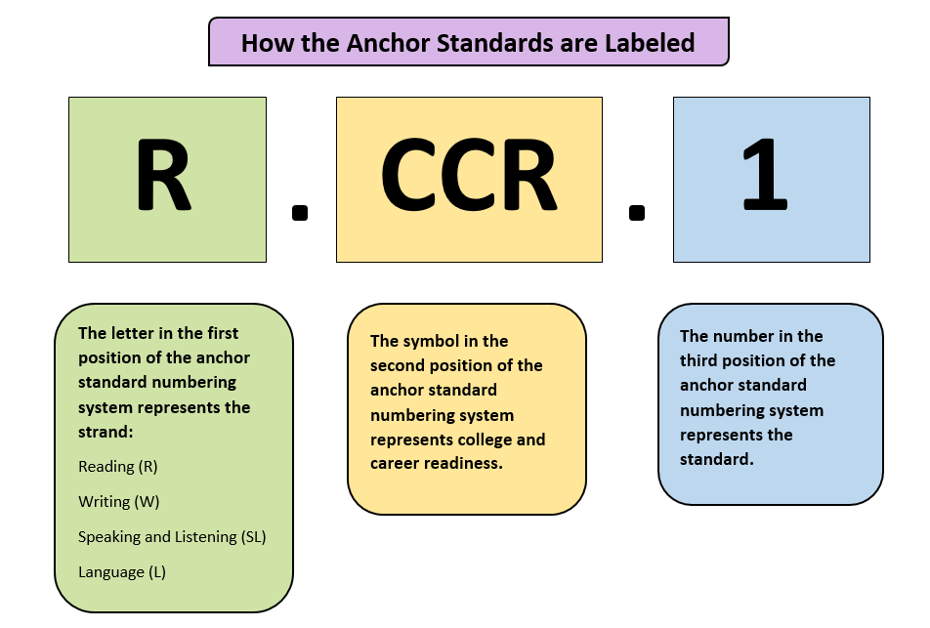

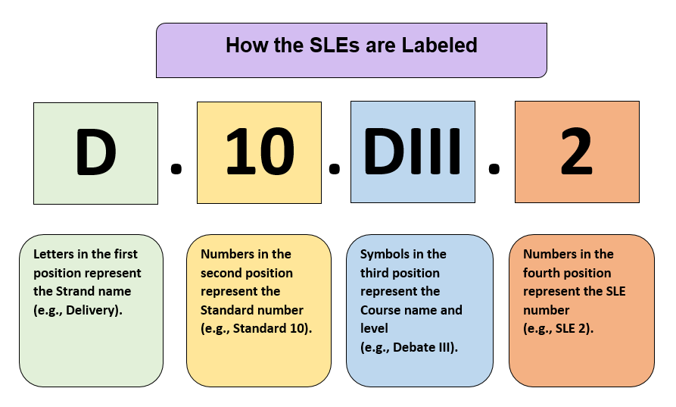

Strand 1: Communication Competencies
Content Standard 1: Students will demonstrate effective intrapersonal communication.
AR ELA Standards
CC.1.PRC.1 | Develop an awareness of the manner in which personal attitudes, values, and beliefs impact professional decision-making and organizational communication | SL.CCR.1, SL.CCR.6
CC.1.PRC.2 | Develop intrapersonal communication skills:  - goal setting  - positive self-concept  - positive self-talk  - self-confidence | SL.CCR.1
CC.1.PRC.3 | Discuss intrapersonal communication concepts (e.g., Johari Window of self-awareness, Maslow’s hierarchy of needs, self-fulfilling prophecy, self-script, fundamental attribution error, fixed vs. growth mindset, imposter syndrome) | SL.CCR.1, SL.CCR.4

Strand 1: Communication Competencies
Content Standard 2: Students will practice communication competencies in their professional interaction with others.
AR ELA Alignment
CC.2.PRC.1 | Analyze the effect of the communication channel on the sending and receiving of messages | SL.CCR.1, SL.CCR.2, SL.CCR.3, SL.CCR.4
CC.2.PRC.2 | Demonstrate appropriate listening skills:  - active listening  - critical listening  - reflective listening | SL.CCR.3
CC.2.PRC.3 | Reduce communication barriers:  - apprehension  - bias  - false assumptions  - loaded terms  - negative nonverbal communication | SL.CCR.3
CC.2.PRC.4 | Identify appropriate business etiquette:  - accepted meeting norms  - appearance (e.g., professional attire, business casual dress, grooming)  - introductions, including shaking hands  - technology usage (e.g., composing emails and texts, conference call conduct) | SL.CCR.1, SL.CCR.5, SL.CCR.6
CC.2.PRC.5 | Evaluate messages for established criteria in a variety of professional situations (e.g., phone conferences, collaborative working groups, staff meetings, keynote speakers, business social media):  - clarity  - delivery  - purpose  - reasoning  - word choice | SL.CCR.3

CC.2.PRC.6 | Identify appropriate language usage for audience and message in variety of professional situations:  - connotation and denotation  - dialect  - industry-specific literacy  - jargon  - slang  - standard English  - vocabulary complexity | SL.CCR.6
CC.2.PRC.7 | Convey intended meaning through effective nonverbal communication:  - facial expressions  - gestures  - paralanguage  - proxemics | SL.CCR.1, SL.CCR.4
CC.2.PRC.8 | Apply conflict-resolution strategies in professional relationships:  - damage control  - exhibit mutual respect  - mediate  - negotiate an outcome  - paraphrase or echo  - recognize conflict-resolution styles (e.g., assertive, aggressive, passive, passive/aggressive)  - table the issue  - spin | SL.CCR.1CR.4
CC.2.PRC.9 | Apply principles of ethical communication:  - integrity (e.g., professional, intellectual, creative)  - open, honest, and responsible interaction with colleagues and clients  - respect for diversity  - adherence to communication policies (e.g., privacy, FERPA, HIPPA, data sharing, communication with press) | SL.CCR.1, SL.CCR.4
CC.2.PRC.10 | Examine leadership styles (e.g., autocratic, authoritative, laissez-faire, democratic, transformational) in order to evaluate an organizational leader’s perspective and reasoning | SL.CCR.3
CC.2.PRC.11 | Examine mass media messages and their effect on professional decision-making:  - bias  - credibility  - propaganda  - purpose | R.CCR.6, SL.CCR.3
CC.2.PRC.12 | Define logical fallacies and their effect on professional decision-making (e.g., slippery slope, bandwagon, false cause, hasty generalization, begging the question, false dilemma) | SL.CCR.3
CC.2.PRC.13 | Develop a social media philosophy regarding one’s own professional digital identity (e.g., internet etiquette, impact of social media use on employers, professional relationships, reputation) | R.CCR.1, R.CCR.6, SL.CCR.4
CC.2.PRC.14 | Identify a variety of social media uses:  - commercial advertising and marketing  - direct sales  - workforce recruitment  - professional networking  - news and information | R.CCR.6
CC.2.PRC.15 | Discuss considerations of social media use in business:  - corporate security breach  - privacy policy  - effect of personal presence on professional image  - permanency of shared information | R.CCR.1, SL.CCR.4

Strand 3: Communications Applications
Content Standard 3: Students will prepare for effective communication in a variety of professional communication situations.
AR ELA Alignment
CA.3.PRC.1 | Adapt a message to the context (e.g., cultural, situational, environmental):  - content  - non-verbal communication  - vocal delivery (e.g., pace, volume, tone) | SL.CCR.4, SL.CCR.5, SL.CCR.6
CA.3.PRC.2 | Prepare a formal address:  - analyze audience  - identify purpose  - research topic  - create outline  - organize content according to appropriate pattern (e.g. chronological, topical, problem-solution, cause-effect)  - cite sources  - practice delivery | SL.CCR.4, SL.CCR.6
CA.3.PRC.3 | Research a topic:  - locate appropriate resources  - evaluate the credibility of sources  - cite sources | SL.CCR.2, SL.CCR.4
CA.3.PRC.4 | Use effective methodology for structuring an address:  - introduction, body, conclusion  - main points  - attention devices  - figurative language  - signposts  - cliffhangers  - summaries | SL.CCR.6
CA.3.PRC.5 | Use technology or other aids (e.g., slideshows, props, posters, videos, audio recordings) | SL.CCR.1, SL.CCR.6
CA.3.PRC.6 | Demonstrate effective delivery skills:  - nonverbal skills (e.g., gestures, facial expressions, eye contact, attire, proxemics)  - platform movement  - verbal skills (e.g., vocal projection, pace, rate, tone) | SL.CCR.4, SL.CCR.6
CA.3.PRC.7 | Demonstrate the ability to give and receive actionable feedback in professional and organizational settings:  - develop criteria for feedback  - deliver feedback using constructive verbal and nonverbal communication  - develop a plan of action based on feedback | SL.CCR.3, SL.CCR.4
Strand 3: Communication Applications
Content Standard 4: Students will participate in a variety of formal and informal professional communication experiences.

AR ELA Alignment
CA.4.PRC.1 | Demonstrate conversation skills in professional settings:  - salutations and greetings  - openers  - questions  - appropriate self-disclosure  - appropriate workplace language and content  - fluidity (e.g., allowing others to speak, allowing others to complete thoughts) | SL.CCR.6
CA.4.PRC.2 | Participate in collaborative discussions in a variety of contexts (e.g., staff meeting, project committee work, task force discussion, strategic planning):  - establishing norms  - creating and following an agenda  - building consensus  - preparing ideas for discussion  - responding to diverse perspectives  - recognizing individual roles (e.g., recorder, task manager, emerging leader) | SL.CCR.1, SL.CCR.2, SL.CCR.4, SL.CCR.5, SL.CCR.6
CA.4.PRC.3 | Participate in mock job interview  - prepare for common questions  - research the interviewer and the company  - prepare a resume  - use appropriate verbal and nonverbal communication  - follow up appropriately | SL.CCR.1
CA.4.PRC.4 | Present informal talks on subjects of professional interests and concerns (e.g., team safety meeting, civic club luncheon, corporate board meeting presentation, service professional interaction with client) | R.CCR.1, R.CCR.2, R.CCR.7, R.CCR.8, R.CCR.9, W.CCR.7, W.CCR.8, W.CCR.9
CA.4.PRC.5 | Present a formal informative address that includes research and citation on a topic related to one’s profession (e.g., professional conference breakout session, continuing education workshop, product demonstration ) | SL.CCR.6
CA.4.PRC.6 | Present a formal persuasive address that expresses the speaker’s opinion, justified by evidence, on an issue of concern related to one’s profession (e.g., professional conference keynote, sales or proposal pitch, fundraising appeal)  - formulate and articulate an opinion or resolution  - support an opinion with arguments based on research and reasoning  - present arguments to support opinion or resolution  - respond to opinions of others with one’s own opinion, justified by research and reasoning | SL.CCR.6

Glossary for Professional Communication (0.5 Credit)

Diversity | Understanding that each individual is unique and recognizing individual differences  (e.g., ability, culture, federally protected categories, gender, race, religion, socio-economic status)
Fixed mindset | The belief that one either is or isn’t good at something, based solely on inherent nature, because it is just who one is  https://sivers.org/mindset
Fundamental attribution error | Tendency to explain someone's behavior based on internal factors, such as personality or disposition, and to underestimate the influence that external factors, such as situational influences, have on another person's behavior  http://study.com/academy/lesson/fundamental-attribution-error-definition-lesson-quiz.html
Growth mindset | The belief that anyone can be good at anything, because one’s abilities are entirely due to one’s actions.  https://sivers.org/mindset
Imposter syndrome | “Chronic self-doubt and a sense of intellectual fraudulence that override any feelings of success or external proof of competence”  https://hbr.org/2008/05/overcoming-imposter-syndrome
Johari Window | Model for self-awareness, personal development, group development, and understanding relationships
Paralanguage | Nonverbal means of communication that accompany speech and convey further meaning  (e.g., facial expressions, gestures, laughter, tone of voice)
Proxemics | Communicating with others by virtue of the relative positioning of your bodies
Self-script | Phrases that a person has heard repeated about themselves that become part of their own self talk (e.g., " You’re a good girl.", "You'll never go anywhere in life.")

