Creator(s): Angie Abbott, Jerry Decker, Kimberly Endsley, Carla Gregory, Dedra Riggs, and Keith Westbrook, Hoxie Public School District
Lesson Title: | “Life’s” Good Intentions 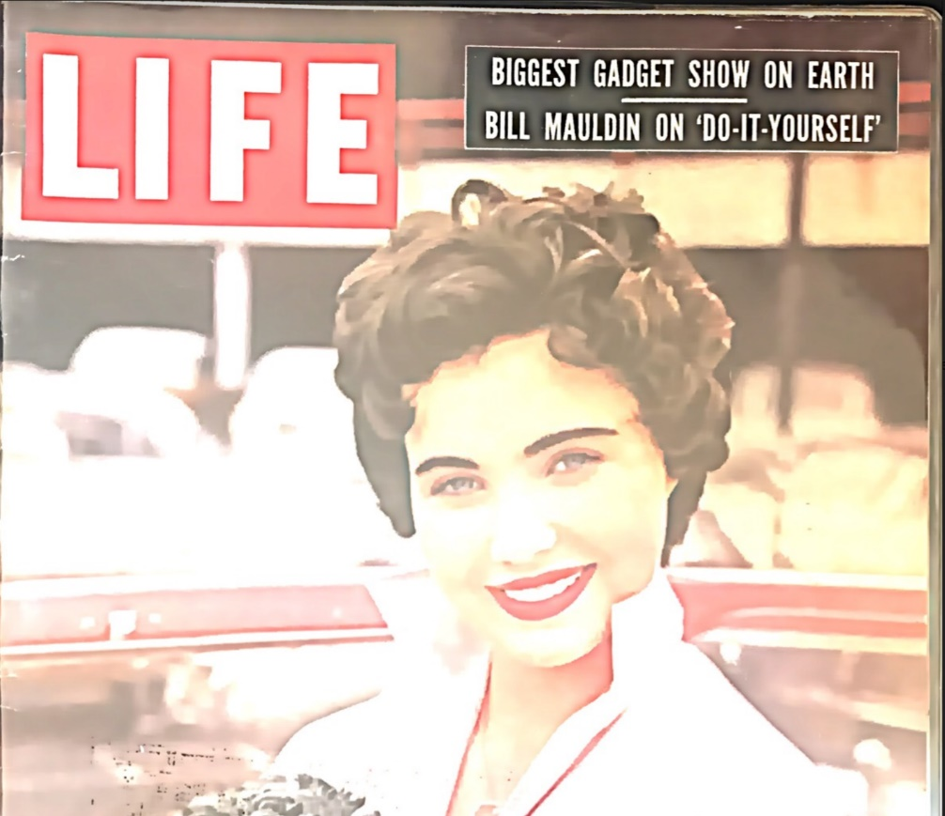LIFE, July 1955.
Estimated Time  (Class Period/s): | 2-3 Class Periods
Grade Level(s): | Grades 4-5
State Standards: | Fourth Grade:  H.13.4.1: Describe ways people’s perspectives shaped the historical sources they created  Fifth Grade  C.3.5.2: Evaluate ways rules and laws change society and reasons why people change rules and laws at the local, state, and federal levels  C.3.5.3: Explain the development of policies to address public problems at the local, state, and federal level
Learning Objective(s): | Students will discuss the effects of the LIFE magazine article on the Hoxie integration, and compare various media articles related to the boycott and re-opening of the school.
Essential Question: | How did news stories affect public opinion?
Materials and Resources: | Life Magazine 1955  Article: “Despite Action of Northeastern Arkansas Ruffians Boycott Fizzles in Hoxie as Democracy Continues to March” (Aug. 1955, AR State Press)  Article: “Hoxie Schools Reopen Monday; Federal Judge Delays Hearing in Court Until Next Monday”  Article: “Integration of School at Hoxie Has Short Life- School Closes” (Aug 26, 1955, AR State Press)  Says/Means/Matters Graphic Organizer
Lesson Plan Details (Substitute Teacher Proof): | - Introduce Life Magazine and briefly discuss historical significance in relation to the Hoxie Integration.  - Teacher relates how the publicity from the LIFE article brought protestors from outside the Hoxie community to agitate for locals to oppose the integration.  - Using close reading strategies, read all or portions of one of the Arkansas State Press articles with the class.  - As the students read they will circle words they do not know or understand, the class will then discuss them to help the students understand these concepts.  - Students will highlight or underline 3 sentences that they believe are important.  - Students will complete the first column of the “Says-Means-Matters” graphic organizer. After completing the “says” portion of the graphic organizer, students will discuss as a class their personal findings on the article in a roundtable fashion.  - Guide students in completing the “means” and “matters” columns.  - In small groups, students will repeat this exercise with the other two articles.  - Students will take part in a class discussion that uses the three articles as they work to answer the essential question, “How is public opinion affected by media with regard to social issues both past and present?” Using “present” allows for students to tie in modern-day examples they have seen in the media.
Formative Assessment(s): | The graphic organizer  In addition to the graphic organizer, students can write a reflection on the following prompt: “Name one way in which media has influenced the way you think.”
Additional Notes: | Lesson should be prefaced with background information about the Life Magazine article about the Hoxie Integration and how it affected the circumstances in the community.  How to Teach With Says-Means-Matters Charts:  - Students will be given a Says/Means/Matter chart for each article to be read.  - Pass out the article (Gazette). Instruct students to read once, silently, underlining words they need to define and phrases they find interesting. When they read a second time (silently to themselves), have them fill in the “says” portion of the chart.  - In a class discussion (roundtable works well), have each student present their “says.” The class will then discuss its meaning and matters, and students will fill in the information as they go.  *It is recommended that a teacher transcribe and adapt these articles for classroom use. More information on how to adapt text for classroom use can be found here: https://teachinghistory.org/teaching-materials/teaching-guides/23560

Sources:
“Hoxie Schools Reopen Monday; Federal Judge Delays Hearing In Court Until Next Monday.” Courtesy of Hoxie School District and Hoxie the First Stand.
ELAchieve. 2010. Constructing Meaning: Explicit Language for Content Instruction. Analytical Notetaking: Says-Means-Matters. Levy. www.elachieve.org.
“Despite Action of Northeastern Arkansas Ruffians Boycott Fizzles in Hoxie as Democracy Continues to March.” Arkansas State Press, August 1955.
“Integration of School at Hoxie Has Short Life- School Closes.” Arkansas State Press, August 26, 1955.
“A ‘Morally Right’ Decision: An Arkansas School Board Does Some Soul Searching and Negro Children Enter Desegregated Classes.” Life, July 25, 1955. Accessed with Google books- https://books.google.com/books?id=wlYEAAAAMBAJ&printsec=frontcover#v=twopage&q&f=false

