T.E.S.S. Module A
TESS History and Rules

Office of Educator Effectiveness
ADE Division of Elementary & Secondary Education
Created June 2021

~Training Facilitation Guide~

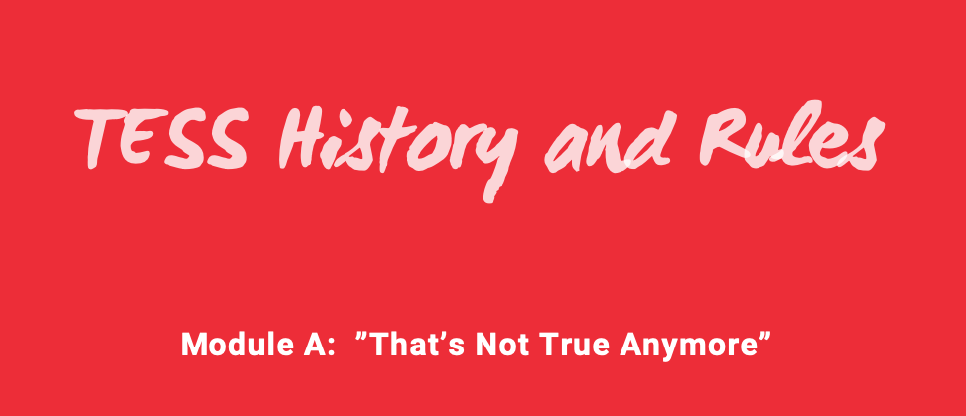

T.E.S.S. Module 2: Professional Growth Plans
“Welcome to this session about the professional growth plans.”

Training Note:
Introductions & if this is face-to-face, any logistics (restrooms, etc.)

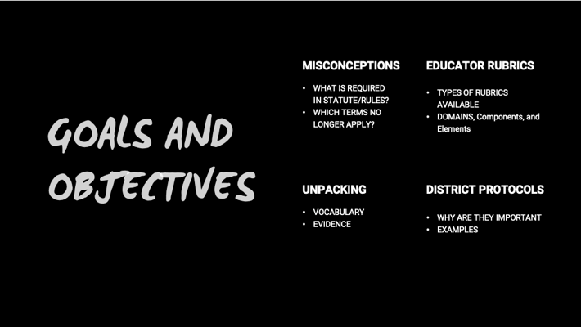 | For so many years, the writing of professional growth plans has been something “done to educators” which has created a sense of compliance. Our goal is to create an environment where educator (teacher and administrator) growth is dynamic, focused, and improves the function of the school/district.  Educators often ask when discussing goals, “do I need to put that into EdReflect?”  Today we have three goals.
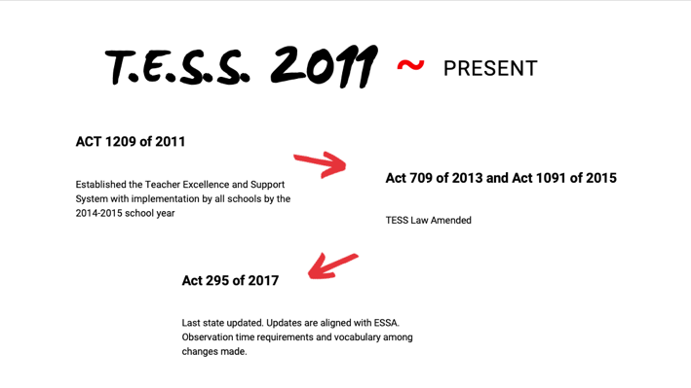 | Partner/Group Share (3-5 minutes)  - Read quote.  - Share your personal story about PGPs. For example: As a teacher I was herded into the computer lab in August where we wrote our pgp together then didn’t look at it again until the midyear review in January.  - Have attendees share their experience as a teacher or administrator. What do they wish they had done differently.
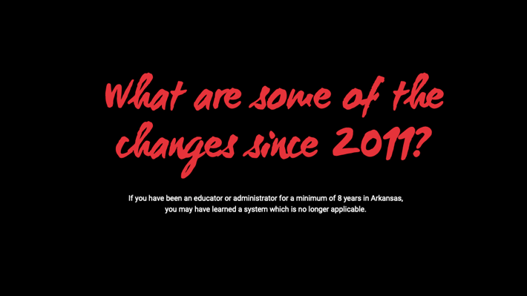 | This section will cover the actual rules of a Professional Growth Plan  “Rules” is linked to the DESE website.  Have learners read  Definitions: “Educator” pg. 5, “Professional Growth Plan” pg. 6, “Teacher” pg. 7  Rules pg. 11, section 6.06-6.08  Ask: “What do you notice?” and Discuss  Ask: “What isn’t specified in rules?” and Discuss Example: Number of goals, frequency of review, requirement to review, due date  Ask: “For the components that are not explicitly stated, does your district have a protocol to answer those components?” and Discuss  Let’s talk about how we can transition from PGP compliance to change of practice.
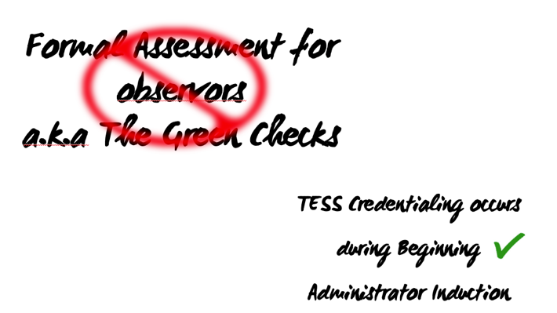 | Have those in the room raise their hand if they were around to receive their 2 green checks. They can share the process if they want bc it was difficult.  Now, we conduct a one day training with coaching follow-up sessions during Beginning Administrator Induction. Only training conducted by the DESE constitutes credentialing. Attending TESS related training by other entities is encouraged, but does not count toward credentialing.
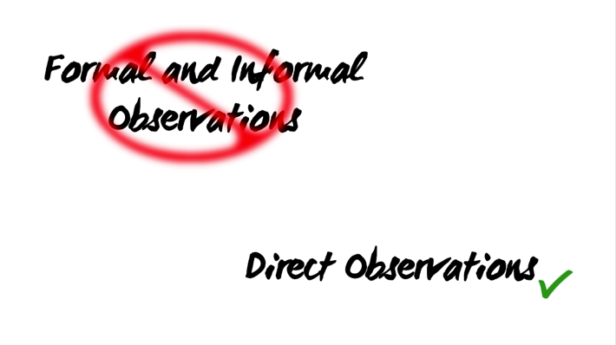 | In the original 2014 rules:  - A formal observation was an announced visit  - Preceded by a preconference  - At 75% of the class period but could be modified to 45 minutes for those teaching a block schedule.  - An informal observation could be unannounced and for a shorter period of time.  The 2017 update did away with both of these terms. The term used now for a physical observation is direct. There are no time requirements specified. Guidance is for the direct observation to be as long as necessary in order to gather quality/sufficient evidence.  What are the impacts of this language?  Do district protocols still use formal and informal observation requirements and/or time?  Do you have to change? No. They are both examples of direct observations.  EdReflect cannot change their buttons so this continues to be present and keep observation types in our vocabulary. The only difference in Edreflect between the two is one requires pre/post conference while the other does not.
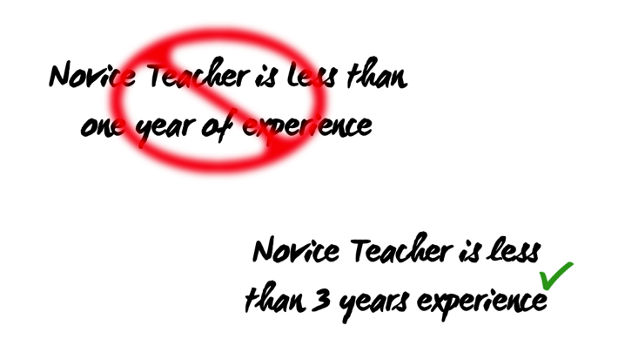 | This has changed novice teacher mentoring from 1 to 3 required years. Novice Teacher Mentoring (NTM) is the responsibility of both the district and local education service cooperative (ESC). The ESC ensures that novices complete the requirements expected by the state. The role of the district to provide internal support.
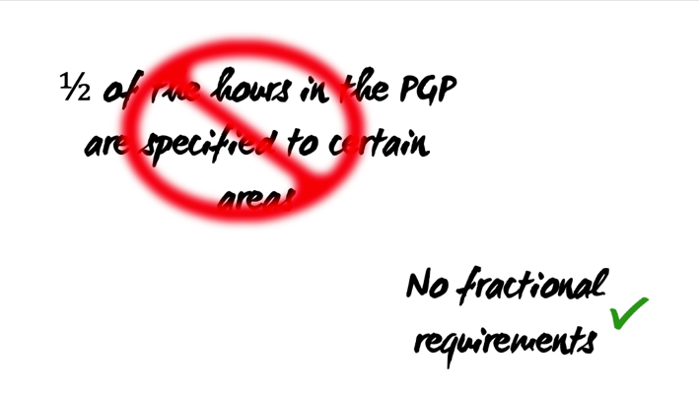 | The state no longer requires hours to be specifically linked. Districts may place requirements on type and quantity of hours by category. The phrase “should advance the teacher’s professional skill” has been consistent throughout time.  A common question we are asked is, “can I used evidence from a classroom walk through for an observation?” Your goal is to collect evidence to provide feedback, coaching, and in the event of a summative rating, sufficient evidence to draw upon for that rating.
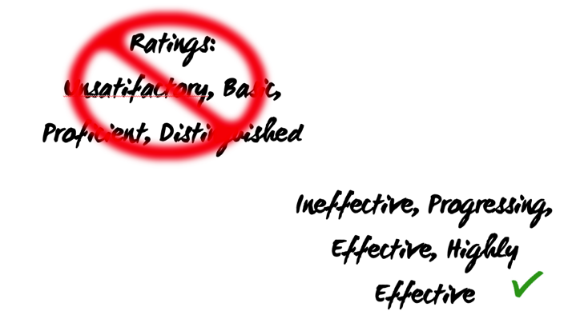
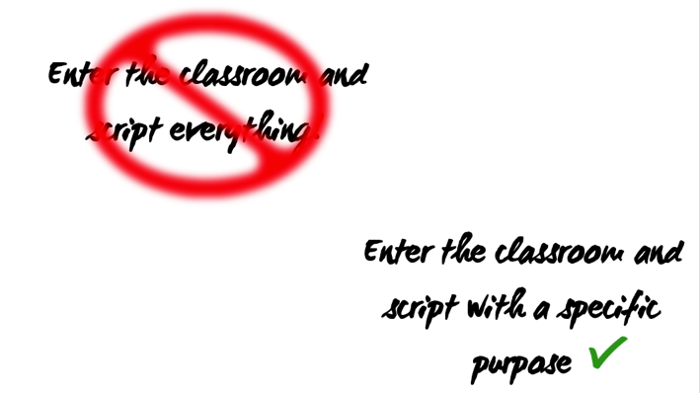
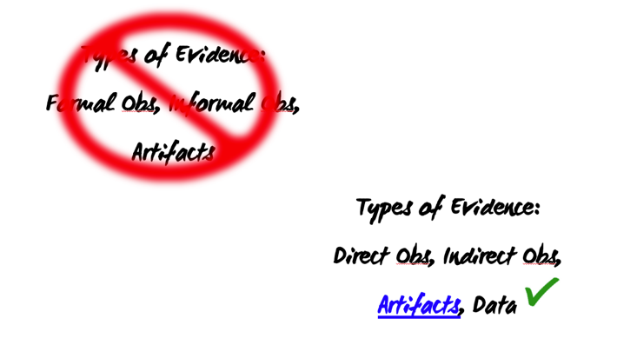 | “Direct observation” means the evaluator is physically present or using appropriate technology to observe the teacher or leader performing essential job functions.  “Indirect observation” means the evaluator observes systems that operate as a result of a teacher’s research, planning, and implementation inside the classroom or in a work-related environment outside of the classroom.  “Data” means: Teacher performance data, which may include without limitation progress on professional learning goals, professional practice ratings, and other indicators determined by the educational entity; Student performance data, which may include without limitation state and local assessments, samples of student work, portfolios, projects, and other indicators determined at the local level; and Overall school performance data. “Data” may include multiple sources of information, such as measures of student growth, school quality, or student success.  “Artifact” means materials that document the educator’s professional practice.  Artifacts is linked to the DESE website page “Examples of Artifacts.”
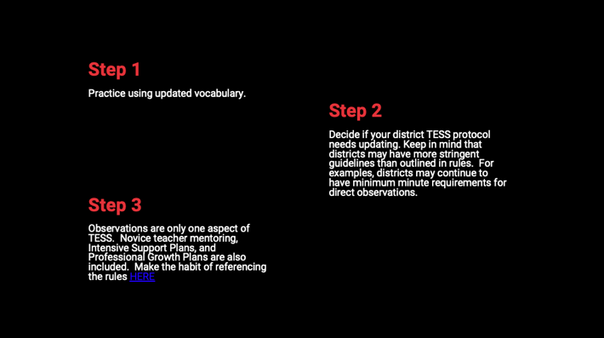 | Take aways:  -Share surprises or take aways. Is there anything you thought was a state rule or term that isn’t?
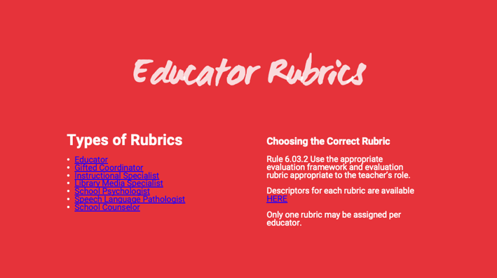
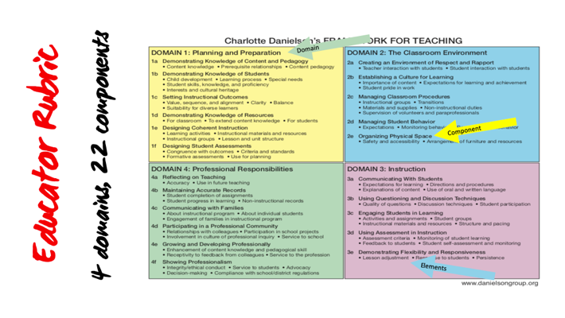
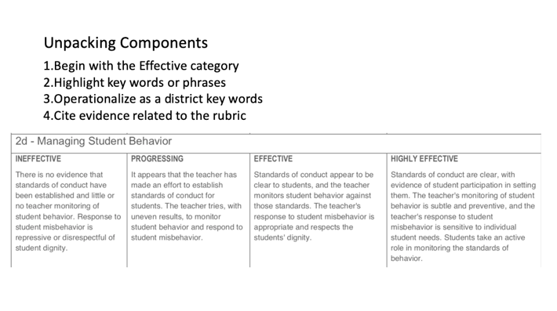 | Read the 4 steps to unpacking a component. Our goal is to enter a classroom understanding effective practices. This process helps an observer focus on specific practices instead of scripting anything and everything.  What are the key terms/phrases you notice in the effective category. Attendees can highlight on their paper copy.
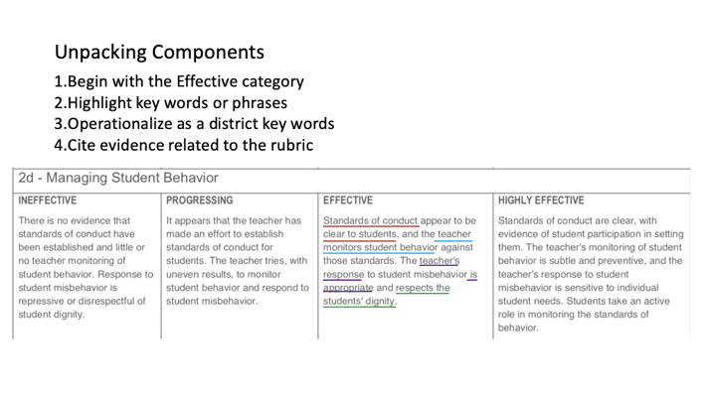 | Group shares responses. Phrases underlined are underlined for demonstrative purposes.  Are there any words that need to be clarified? Ex. What does “appropriate” mean? Are all observers and teachers in your building/district on the same page regarding vocabulary?  What are examples of evidence you might see that the teacher monitors student behavior? How would you cite that a teacher’s response to misbehavior is appropriate?
 | What are the key terms/phrases you notice in the effective category. Attendees can highlight on their paper copy.
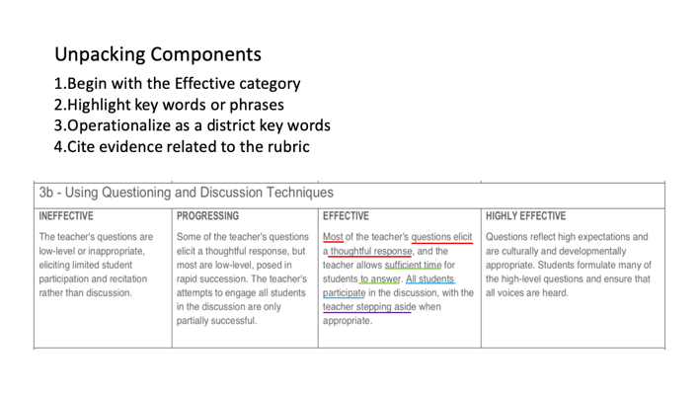 | What are the key terms/phrases you notice in the effective category. Attendees can highlight on their paper copy.  Which key terms need to be operationalized? What is “sufficient?” “most?  Reminder, the reason understanding the terms is because as the observer, you must collect evidence to support the rating. What are some ways you could document sufficient time to answer? How would you document teacher stepping aside?
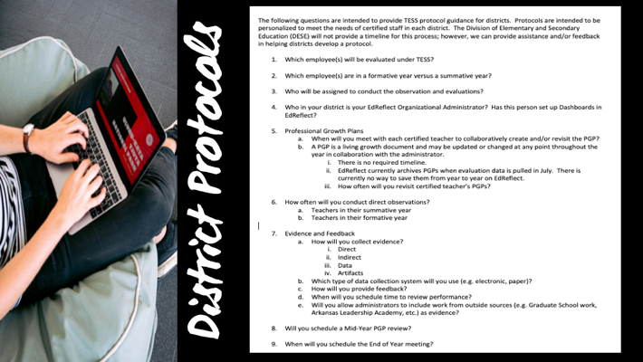 | Do you know if your district has a written protocol? If so, do you know where to find it?  Read through the number questions. Discuss as needed.

