T.E.S.S. Module B
Professional Growth Plans

Office of Educator Effectiveness
ADE Division of Elementary & Secondary Education
Created June 2021

~Training Facilitation Guide~

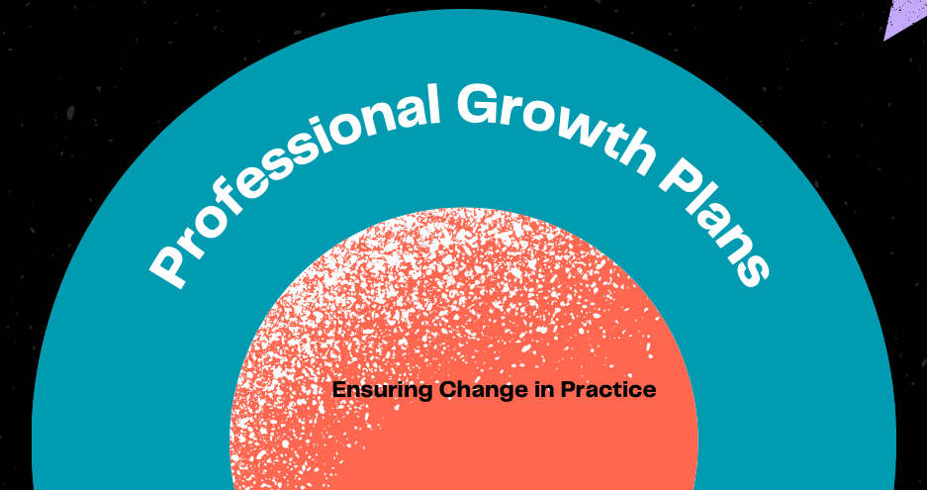

T.E.S.S. Module 2: Professional Growth Plans
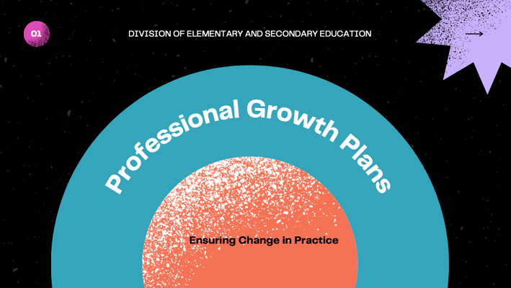 | “Welcome to this session about the professional growth plans.”  Training Note:  Introductions & if this is face-to-face, any logistics (restrooms, etc.)
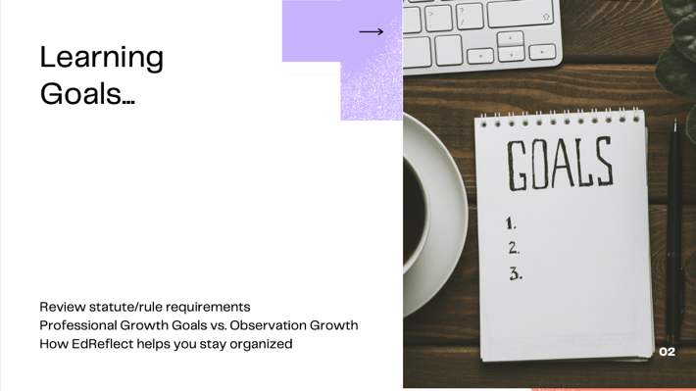 | For so many years, the writing of professional growth plans has been something “done to educators” which has created a sense of compliance. Our goal is to create an environment where educator (teacher and administrator) growth is dynamic, focused, and improves the function of the school/district.  Educators often ask when discussing goals, “do I need to put that into EdReflect?”  Today we have three goals.
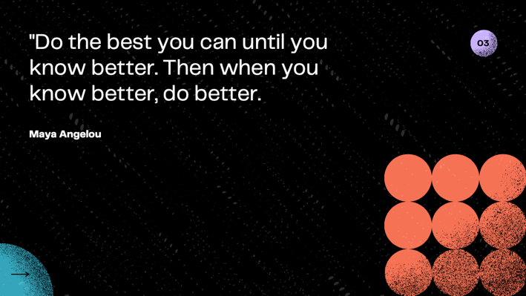 | Partner/Group Share (3-5 minutes)  - Read quote.  - Share your personal story about PGPs. For example: As a teacher I was herded into the computer lab in August where we wrote our pgp together then didn’t look at it again until the midyear review in January.  - Have attendees share their experience as a teacher or administrator. What do they wish they had done differently?
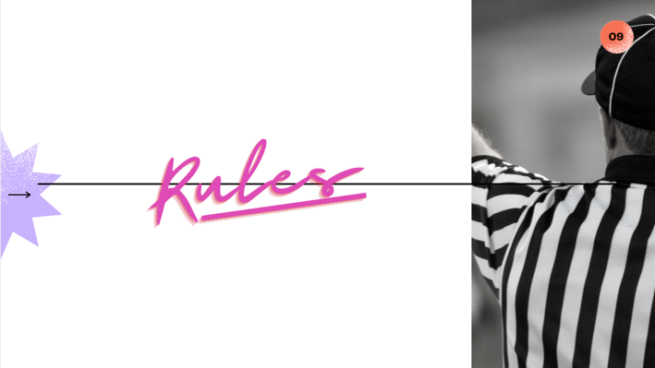 | This section will cover the actual rules of a Professional Growth Plan  “Rules” is linked to the DESE website.  Have learners read  Definitions: “Educator” pg. 5, “Professional Growth Plan” pg. 6, “Teacher” pg. 7  Rules pg. 11, section 6.06-6.08  Ask: “What do you notice?” and Discuss  Ask: “What isn’t specified in rules?” and Discuss Example: Number of goals, frequency of review, requirement to review, due date  Ask: “For the components that are not explicitly stated, does your district have a protocol to answer those components?” and Discuss  Let’s talk about how we can transition from PGP compliance to change of practice.
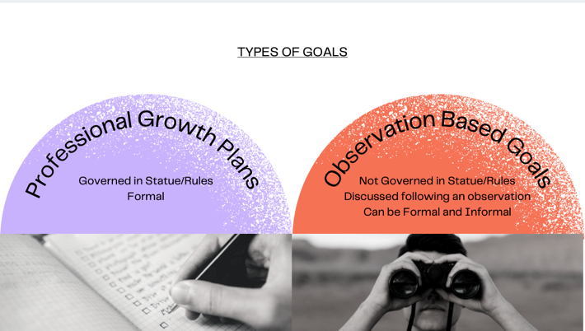 | In a school there are two types of goals:  - A required PGP which contains goals and is entered into EdReflect  - Goals that are based on observation of a teacher’s practice.  Sometimes observation goals are also entered into EdReflect. Observations goals are typically narrow in focus and may be informal and/or quick hitting. Example: After asking a question, count to 7 in your head before calling on a student to respond.  What other observation related goals might you may offer a teacher?
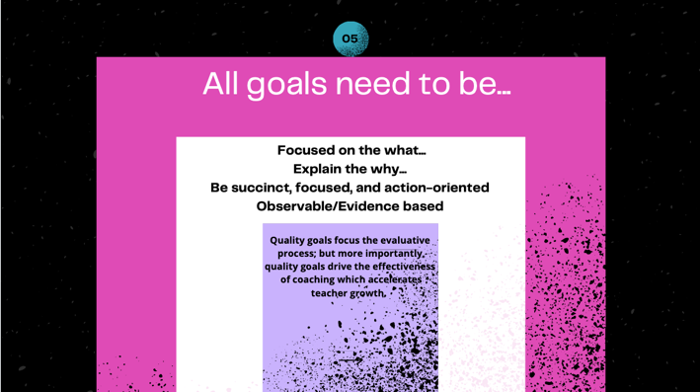 | Regardless of the type of goal, it should be…  Read the four characteristics of goals.  Sometimes these are answered in EdReflect, which we will visit later, other times they may be verbal.  Using the above example of wait time, following an observation I might say,  “Wait time is very important for students. It increases the likelihood to volunteer appropriate answer and less likely to say ‘I don’t know. This week I want you to practice counting to 7 in your head following each question. I’ll come by next week and follow-up with you.”  This conversation is succinct, focused, explains the why and is evidence based.  Thoughts?
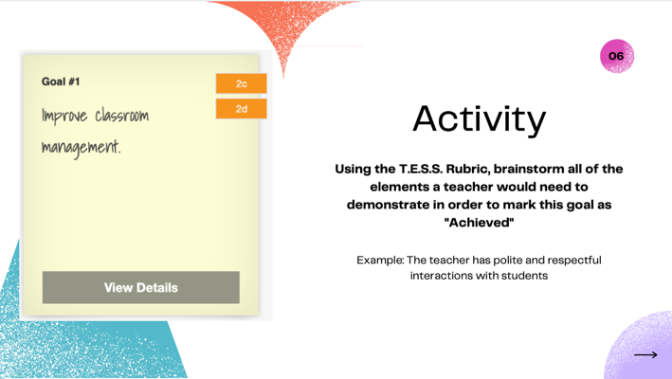 | Next, we will practice ensuring goals are succinct, focused, and action-oriented. On the screen is an example of a goal that has been entered into EdReflect.  What do you notice about this goal? (broad, not focused, etc.)  How long do you think it takes for a teacher to become effective in “classroom management?”  This goal is very broad. Let’s complete the activity on the board. (Hand out TESS framework) Our goal is to brainstorm all elements an educator would need to demonstrate effectiveness before being able to mark this goal as “complete” in EdReflect. (Make a list on a board or chart)
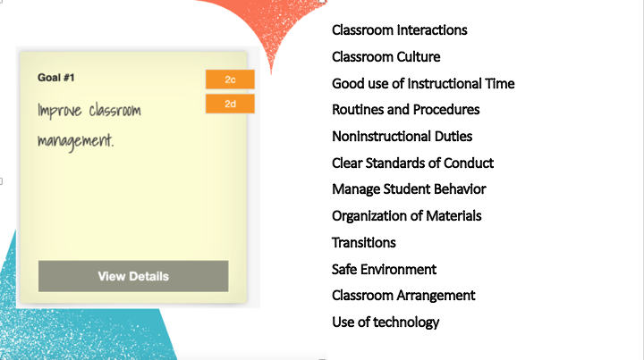 | Example list of what a teacher would need to be effective at before this PGP goal could be marked complete.  ?How long do you think it would take before a teacher would be effective in all areas?  What would be a better goal?
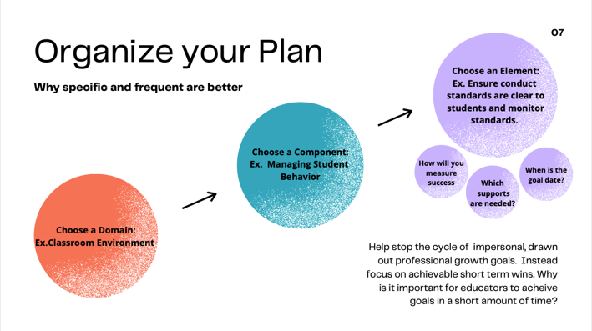 | This chart is designed to help an educator focus a broadly written goal.  Admin: I noticed you want to improve the environment in your classroom. That is a really big goal, so let’s look at the framework and see if we can be more specific. Which component of classroom environment are you thinking about?  Teacher: Well I really need to improve on the behavior of my student.  Admin: Ok, that is 2d. Which element of student behavior do you want to improve.  Teacher: Well, when I am teaching whole group everything is fine, but the students get off task and too loud the moment we break into small groups.  Admin: That is frustrating I’m sure. Let’s collaborate on goal specifics.  At this point the educator now has a specific professional goal. Rules do not require a professional growth goal, but instead, a professional growth plan. To complete the plan, educators should elaborate with specific steps. Let’s take a look at what is located within EdReflect to help complete the plan.
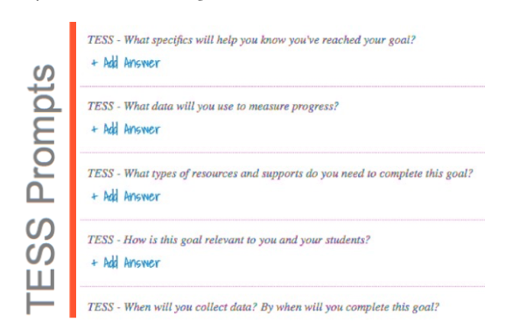 | These questions are housed in EdReflect as a support for educators. These questions are not required in rules and may be modified at the district level. The questions in EdReflect however cannot be modified. A paper form is available on the DESE website and can be uploaded as an artifact if needed.  By completing these, or similar type questions, an educator transitions from a goal to a plan. These prompts also help a supervisor not have to “wing it” when it
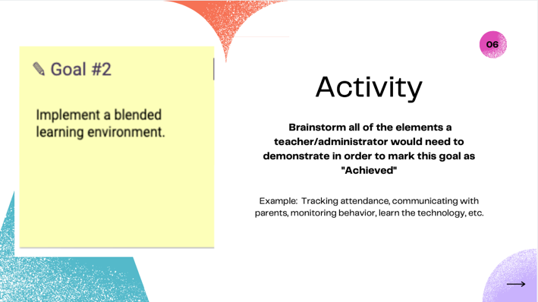 | Repeat earlier activity and have attendees brainstorm the elements a teacher would not demonstrate effectiveness for “implement a blended learning environment.”
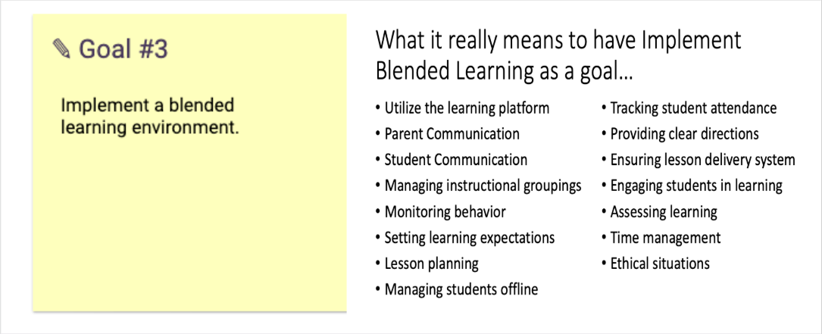 | A sample list of brainstormed idea. Reinforces how much a teacher/administrator would need to be effective at before this goal would be considered “complete.”
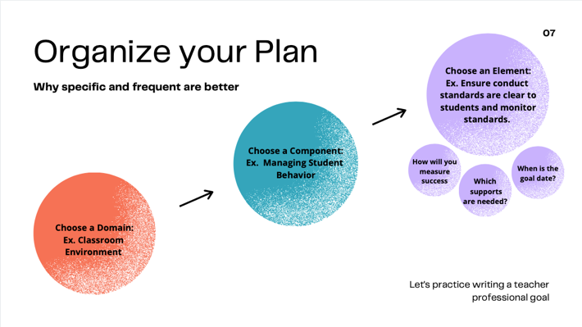 | Repeat process:  Admin: You want to implement a blended learning environment. Tell me more about that.  Teacher: Well I don’t really feel comfortable with the learning management system.  Admin: So, you need to grow professionally around the LMS. That is 4e. What specifically about the LMS do you to improve?  Teacher: I don’t feel comfortable about logging in and navigating.  Admin: Ok, let’s write that as a plan.  The awesome part of this process is that we don’t want a teacher to spend 9 months learning how to log in and navigate. The administrator wants to set a goal (2 weeks, 2 months, etc.), check for completion then start the process over with a new goal.
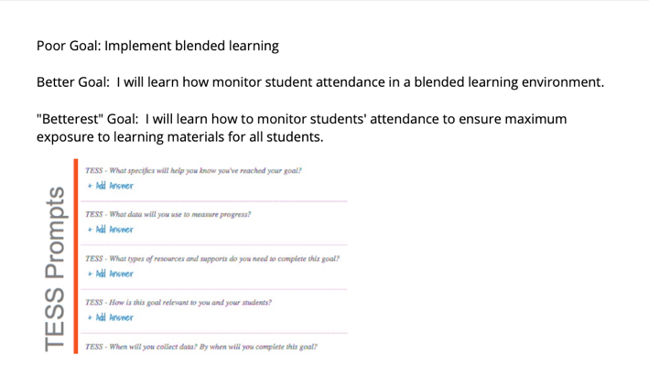 | Again, these TESS prompts are helpful in this process.
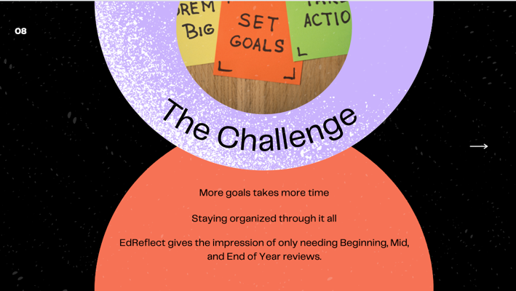 | What are the challenges of this process?
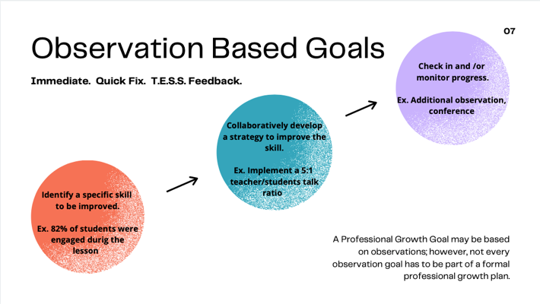 | The second type of goal doesn’t require an official plan, even though it is best practice to follow the same process. Observation based goals are designed to be fast acting. In this example, a teacher needs to engage the additional 18% of students. To accomplish this, the teacher is going to implement a 5:1 teacher/student talk ratio. Collaboratively a goal, timeframe and follow up have been designated.  Often, we are asked, “but do I have to put this in EdReflect?” Keep in mind that EdReflect is a tool designed to help an educator stay organized. It is not intended to be a burden.  The only difference is that an observation-based goal may only be recorded in an educator “Feedback Form” or “Post Observation Form/Conference” in EdReflect. These could also be added as a “post-it” goal in EdReflect too. Of course, these goals might also be documented by an email, notes, etc.
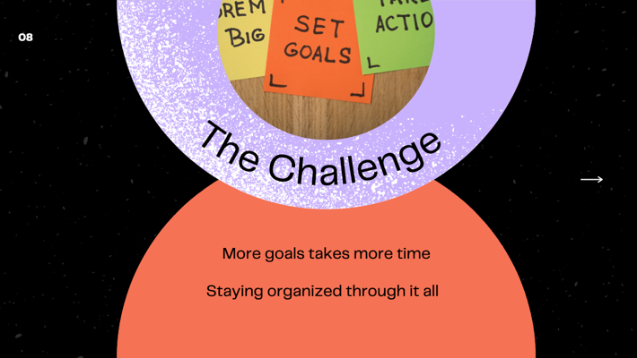 | The challenge is the same. Goal setting, feedback and follow up conversations take time and organization. They are however the best way to ensure a change in practice.  Let’s wrap up our session today by discussing ways you all stay organized with goals. Let attendees talk in pairs then share or share as a whole group.
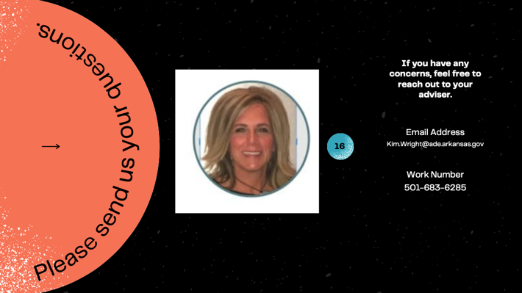 | Contact Information:  Kim.Wright@ade.arkansas.gov

