T.E.S.S. Module H
EdReflect: An Overview

Office of Educator Effectiveness
ADE Division of Elementary & Secondary Education
Created June 2021

~Training Facilitation Guide~

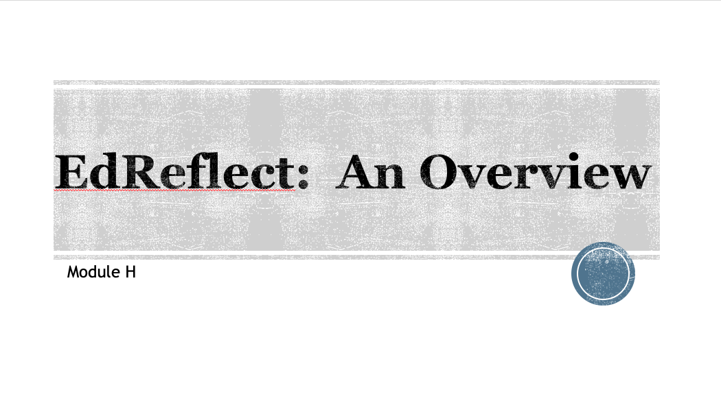

T.E.S.S. Module 2: Professional Growth Plans
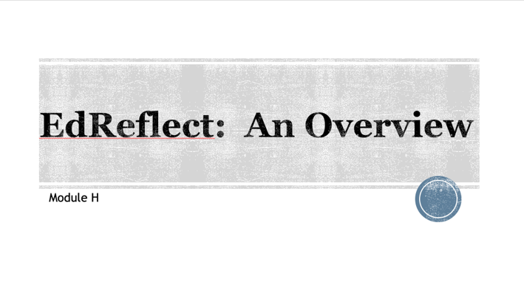 | “Welcome to this session providing an overview of TESS.”  Training Note:  Introductions & if this is face-to-face, any logistics (restrooms, etc.)
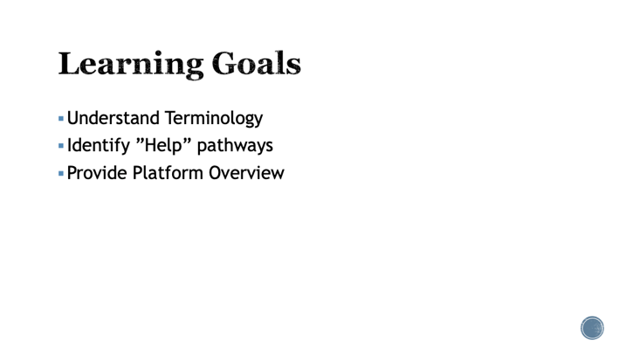 | Review learning goals.  EdReflect is not TESS. It is simply a platform designed to make the implementation of TESS more efficient by providing educator a one stop for data and observation note collection. EdReflect includes the required PGP, Observations, and Summative Evaluation calculations.
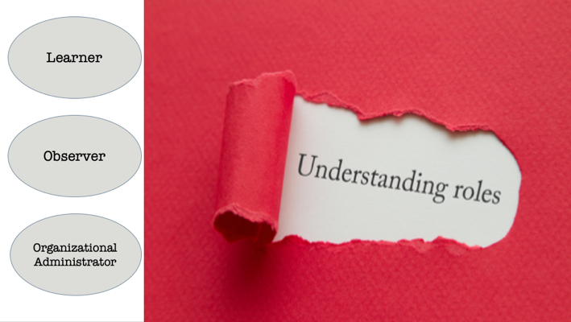 | There are three roles:  Learner: The educator/administrator providing evidence, completing the professional growth plan, being “evaluated,” or in a formative year.  Observer: This is the supervisor who is responsible for completing observations, collecting evidence, approving and following up on professional growth plans  Organizational Administrator: The person designated by the district who assigns roles/observers and is the liason between the DESE and district.  One misconception is that the Organizational Administrator (Org Admin) is able to see everything an observer inputs into EdReflect. The only way an observer can view this information is if he/she is assigned to a particular learner. There is a reporting feature called “Insights” which allows district/building level administrators to view observations data of a school. This only reflects information such as # of formals, # of pgps completed, etc.  It is possible for one person to have all 3 roles at the same time. You may be a building administrator who conducts observations, be a learner with your superintendent while also serving as your district org admin.  At no point can anyone at DESE see the information in EdReflect. Because of this, it is most helpful to contact EdReflect support when there is an issue.
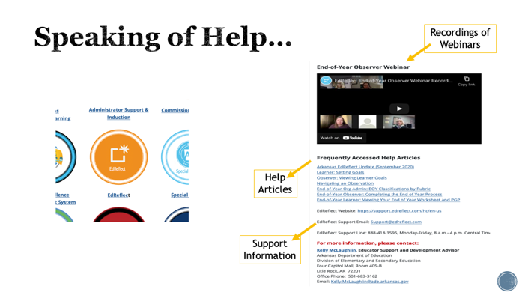 | A link to EdReflect support is located on the DESE webpage by using the Administrator tab under ”Stakeholders (pic is linked)
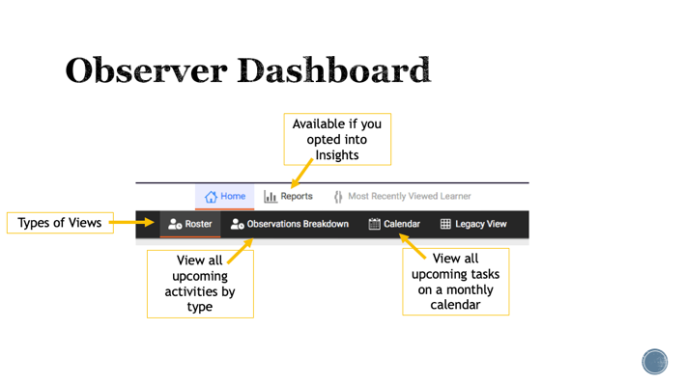 | The Observer dashboard offers a variety of views to allow the Observer to choose which view works best for their workflow.  Roster , Observations Breakdown, Calendar, Legacy
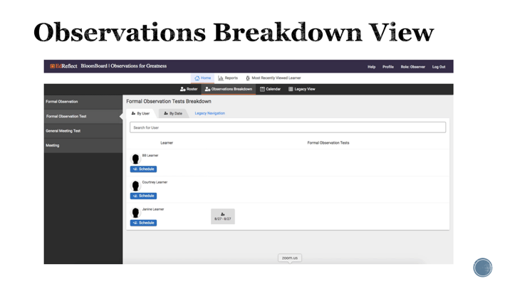 | The Observations Breakdown View  This view allows the Observer to choose and schedule an activity listed on the left-hand side of the page for their Learners. Learners the activity should not be scheduled for will not appear in this view.  This view allows you to see all scheduled activities of a specific type by both Learner and by Date.Once an activity is scheduled, you can see it in the Learner row on the User tab or on the calendar which shows two weeks of scheduled appointments.
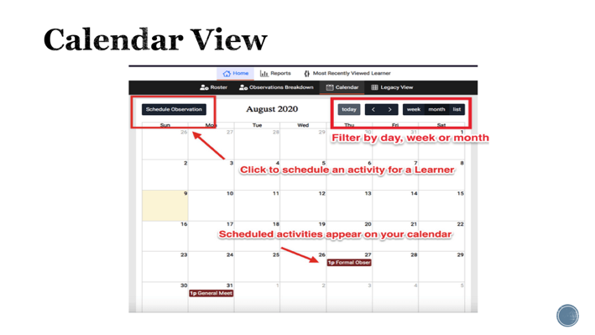 | The Calendar View  The Calendar view allows Observers to view scheduled activities on a calendar.  Observers can customize the view to display by day, week, or month.  Click the Schedule button to schedule a new activity from this view.  chart)
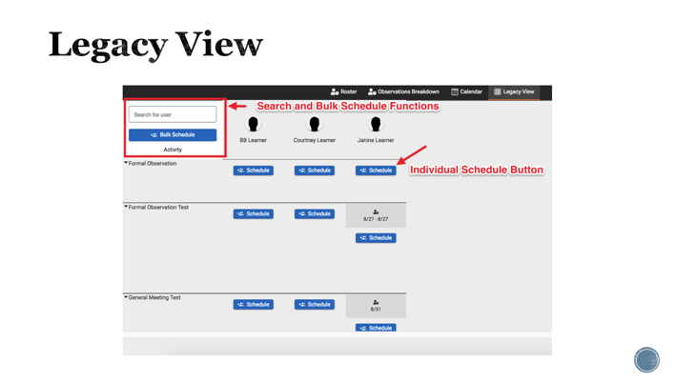 | The Legacy View  The Legacy view is similar to the original Observer dashboard on EdReflect.  Learners are listed horizontally across the top of the page while activities are listed vertically on the left-hand side.  Bulk and Individual Scheduling is available.  Use the search function to search by either first or last name to quickly locate a Learner.  Scheduled activities will appear as a grid by learner/activity.
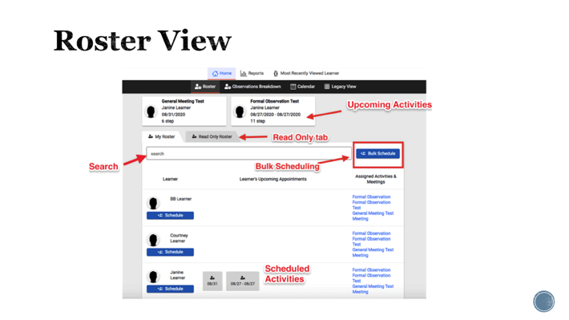 | The My Roster tab will list all assigned Learners alphabetically. Each Learner row will display any upcoming scheduled activities. At the end of the Learner row, you can click an activity name to schedule for that learner. Bulk Scheduling is also available.  Read Only Roster tab will show any Learners you have read-only access to as well as which activities have been scheduled so you can view them.  Use the search function to search by either first or last name to quickly locate a Learner.  Upcoming appointments will display at the top of your Roster view.
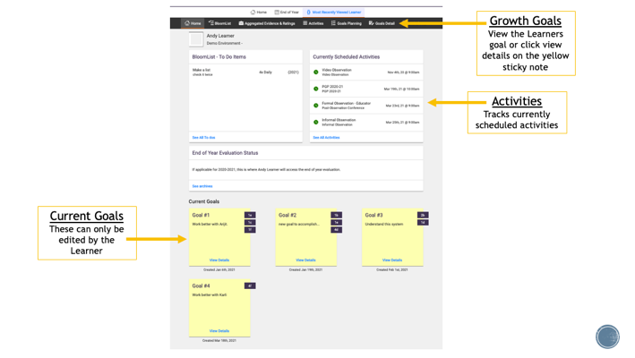 | Repeat earlier activity and have attendees brainstorm the elements a teacher would not demonstrate effectiveness for “implement a blended learning environment.”
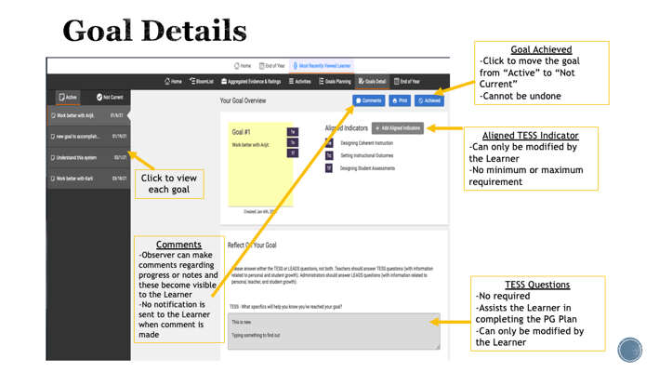 | Repeat process:  Admin: You want to implement a blended learning environment. Tell me more about that.  Teacher: Well I don’t really feel comfortable with the learning management system.  Admin: So you need to grow professionally around the LMS. That is 4e. What specifically about the LMS do you to improve?  Teacher: I don’t feel comfortable about logging in and navigating.  Admin: Ok, let’s write that as a plan.  The awesome part of this process is that we don’t want a teacher to spend 9 months learning how to log in and navigate. The administrator wants to set a goal (2 weeks, 2 month, etc.), check for completion then start the process over with a new goal.
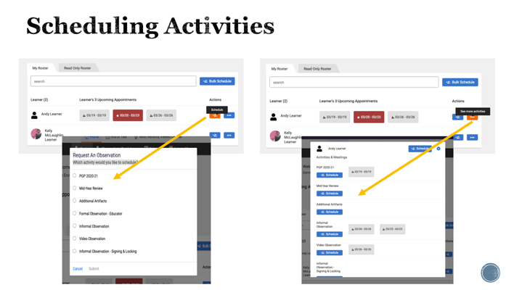 | Again, these TESS prompts are helpful in this process.
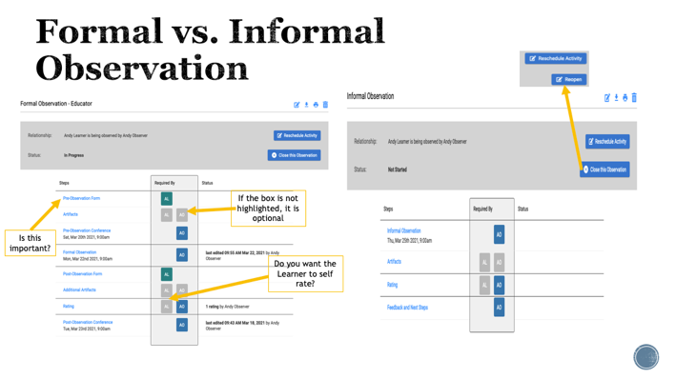 | What are the challenges of this process?
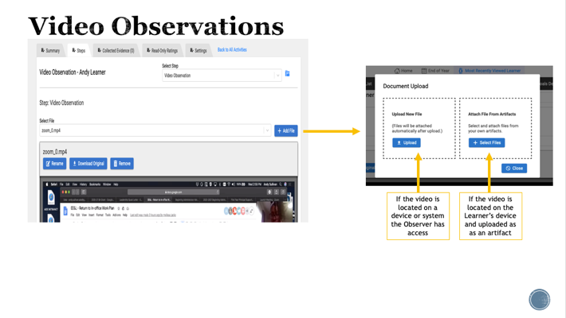 | One of the perks of video observations is the video takes the place of some scripting. For example, instead of needing to script the question asked, you can focus on adding the comment of “DOK 2” or “recall/response.”
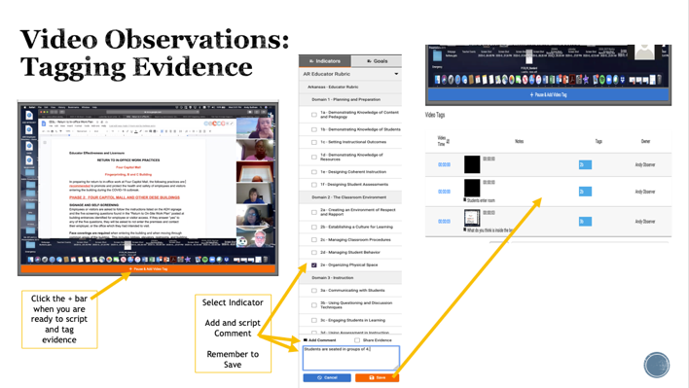 | The challenge is the same. Goal setting, feedback and follow up conversations take time and organization. They are however the best way to ensure a change in practice.  Let’s wrap up our session today by discussing ways you all stay organized with goals. Let attendees talk in pairs then share or share as a whole group.
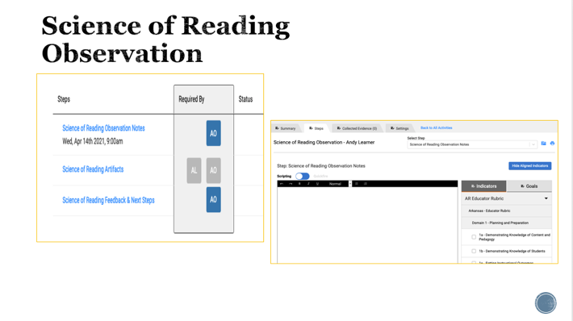 | You will notice the Science of Reading Observations does not allow you to tag evidence to a SOR indicator. This is because a Learner may only be assigned one rubric, in this instance it is the Educator Rubric. The positive of using the option is the ability to search for all SOR observations when reviewing evidence for proficiency. The downside is you cannot rate using this option, preventing the Observer from applying a rating of any of the components.
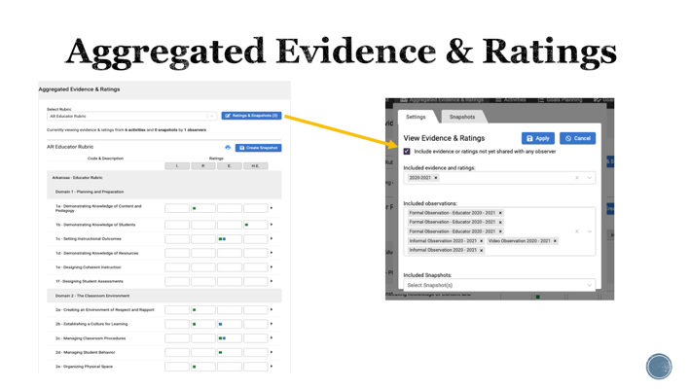 | This view shows ratings assigned for the year. To view specific ratings, for example only formal observations, click the “x” to unselect the other types of observations.
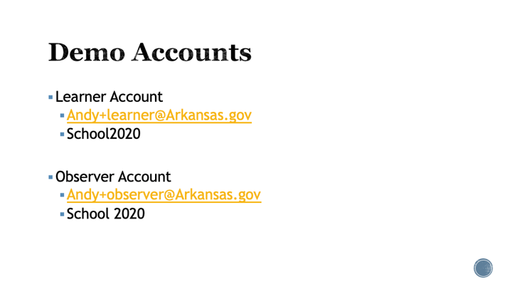 | If you want to investigate what it looks like for a Learner to upload evidence, see the preobservation questions, complete the PGP questions, use the Learner information as your username and password to log in. If you want to practice in the observer platform without messing up your account, do the same for the observer demo. The portal site is the same as used for regular Edreflect.
